**Adding version control**

In this section, we'll learn how to set up and use Git, which is a version control system. Git will let us keep track of the changes to our project over time. This is really useful when something goes wrong and we need to revert to a previous state in the project where things were working. It's also super useful for backing up our work.

**Installing Git**

To get started, we will need to install Git on the computer, but luckily for us it is a really simple installation process. It's one of those installers where we just click on the Next button through a few steps. So let's go ahead and do that.

1. [We can grab the installer by heading over to the browser and going to git-sc m.com.](http://git-scm.com/)

*Before we go ahead and install it, I want to show you the link to the book called Pro Git (*[*https://git-scm.com/book/en/v2*](https://git-scm.com/book/en/v2)*). It is a free book and also available for online reading. It covers everything that Git has to offer. We'll be looking at some of the more basic features in this chapter, but we could easily create an entire course on Git. There actually are Udemy courses just on Git and GitHub, so if you want to learn more than what we cover in this book, I'd recommend reading this book or checking out a course, whatever your preferred learning method is.*

1. Click on the download button present on the right-hand side of the home page, for all the operating systems, whether it's Windows, Linux, or macOS. This should take us to the installer page and we should be able to [get the installer downloading automatically. If you see any problem with Sou rceForge.net, then we may have to actually click on it to download manually](http://SourceForge.net/) in order to start the download.
2. Once the installer is downloaded, we can simply run it.
3. Next, move through the installer:

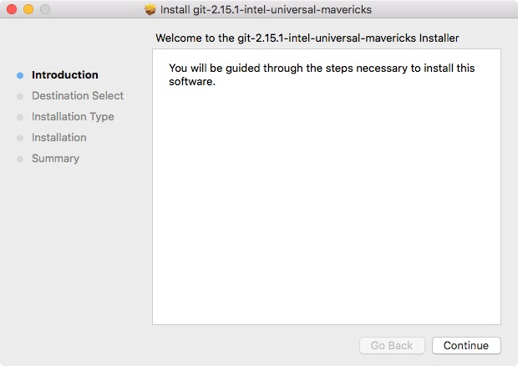

1. Click on Continue and install the package:

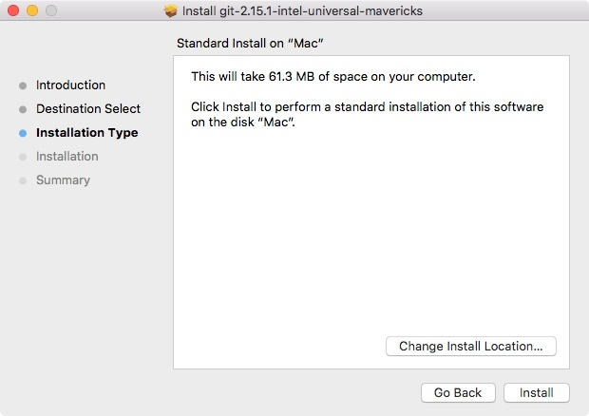

1. Once it's done, we can go ahead and actually test that things installed successfully:

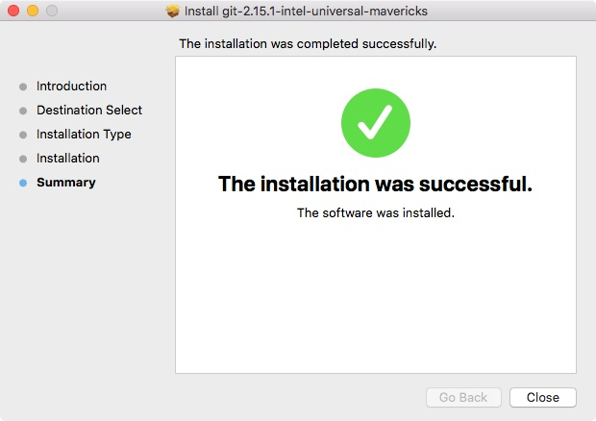

**Git on macOS**

If you're on macOS, you'll need to launch the package installer and you might get the following message box saying that it's from an unidentified developer:

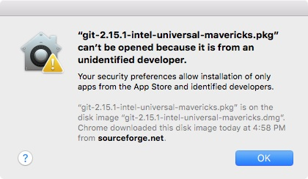

This is because it is distributed via a third party as opposed to being in the macOS App Store. We can go ahead and right-click on the package, then click on the Open button and confirm that we do indeed want to open it.

Once you're at the installer, the process is going to be pretty simple. You can essentially click on Continue and Next throughout every step.

**Git on Windows**

If you're on Windows though, there is an important distinction. Inside the installer you're going to see a screen just like this:

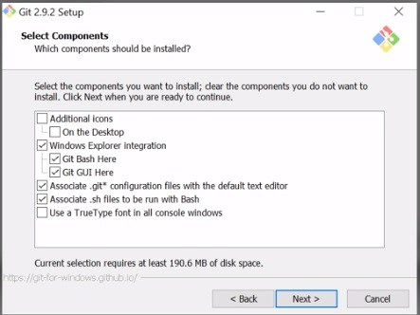

It is really important that you also install Git Bash as shown in the screenshot. Git Bash is a program that simulates a Linux-type Terminal, and it's going to be really essential when we create our SSH keys in the next section to uniquely identify our machine.

**Testing the installation**

Now, let's move in to the Terminal to test the installation. From the Terminal we can go ahead and run git --version. This is going to print a new version of Git we have installed: **git --version**

As shown in the following screenshot, we can see we have git version 2.14.3:

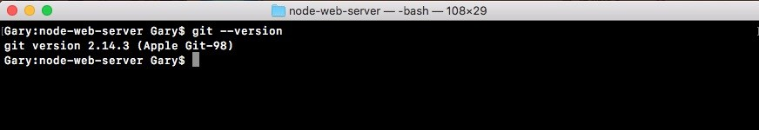

*Now if you have your Terminal still open and you're getting an error like git command not found, I'd recommend trying to restart your Terminal. Sometimes that is required when you're installing new commands such as the git command, which we just installed.*

**Turning the node-web-server directory into a Git repository**

With successful installation of Git, we are now ready to turn our node-web-server directory into a Git repository. In order to do this, we'll the following command: **git init**

The git init command needs to get executed from the root of our project, the folder that has everything that we want to keep track of. In our case, node-webserver is that folder. It has our server.js file, our package.json file, and all of our directories. So, from the server folder, we'll run git init:



This creates a .git directory inside that folder. We can prove that by running the ls -a command:

**ls -a**

As shown in the following screenshot, we get all of the directories including the hidden ones and right here I do indeed have .git:

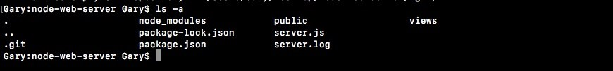

*For Windows, go ahead and run these commands from the Git Bash.*

Now this directory is not something we should be manually updating. We'll be using commands from the Terminal in order to make changes to the Git folder.

*You don't want to be going in there manually messing around with things because there's a pretty good chance you're going to corrupt the Git repository and all of your hard work is going to become useless. Now obviously if it's backed up, it's not a big deal, but there really is no reason to go into that Git folder.*

Let's use the clear command to clear the Terminal output, and now we can start looking at exactly how Git works.

**Using Git**

As mentioned earlier, Git is responsible for keeping track of the changes to our project, but by default it doesn't actually track any of our files. We have to tell Git exactly which files we want it to keep track of and there's a good reason for this. There are files in every project that we're most likely not going to want to add to our Git repo, and we'll talk about which ones and why later. For now let's go ahead and run the following command:

**git status**

Now all these commands need to get executed from inside of the root of the project. If you try to run this outside a repository, you'll get an error like git repository not found. What that means is that Git cannot find that .git directory in order to actually get the status of your repository.

When we run this command, we'll get some output that looks like this:

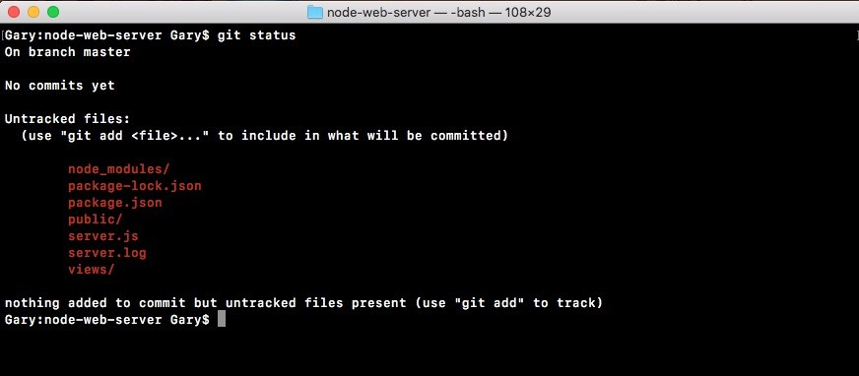

The important pieces for now is the Untracked files header and all of the files underneath it. These are all of the files and folders that Git seized, but it's currently not tracking. Git doesn't know if you want to keep track of the changes to these files or if you want to ignore them from your repository.

Now the views folder, for example, is something we definitely want to keep track of. This is going to be essential to the project and we want to make sure that whenever someone downloads the repository, they get the views folder. The log file on the other hand doesn't really need to be included in Git. In general our log files are not going to be committed, since they usually contain information specific to a point in time when the server was running.

As shown in the preceding code output, we have server.js, our public folder, and package.json. These are all essential to the process of executing the app. These are definitely going to be added to our Git repository, and the first one above we have is the node_modules folder. The node_modules folder is what's called a generated folder.

Generated folders are easily generated by running a command. In our case, we can regenerate this entire directory using npm install. We're not going to want to add Node modules to our Git repository because its contents differ depending on the version of npm you have installed and depending on the operating system you're using. It's best to leave off Node modules and let every person who uses your repository manually install the modules on the machine they're actually going to be running the app.

**Adding untracked files to commit**

Now we have these six folders and files listed, so let's go ahead and add the four folders and files we want to keep. To get started, we'll use any git add command. The git add command lets us tell the Git we want to keep track of a certain file. Let's type the following command: **git add package.json**

After we do this, we can run it git status again, and this time we get something very different:

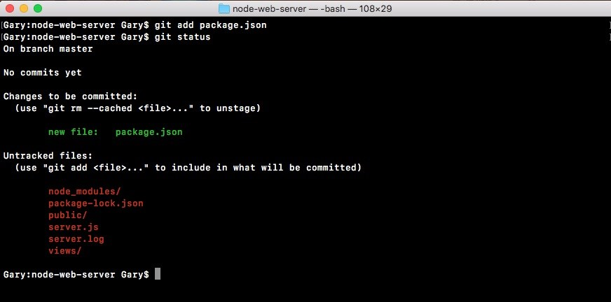

Now we have an Initial commit header. This is new, and we have our old Untracked files header. Notice under Untracked files, we don't have package.json anymore. That is moved up to the Initial commit header. These are all of the files that are going to be saved, also known as committed, when we make our first commit. Now we can move on adding the 3 others. We'll use a git add command again to tell Git we want to track the public directory. We can run a git status command to confirm it was added as expected:

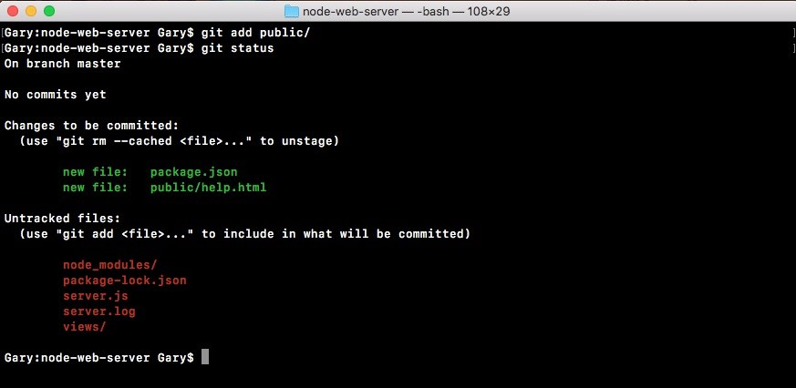

As shown in the preceding screenshot, we can see the public/help.html file is now going to be committed to Git once we run a commit.

Next up we can add server.js with git add server.js, and we can add the views directory using git add views, just like this:

**git add server.js git add views/**

We'll run a git status command to confirm:

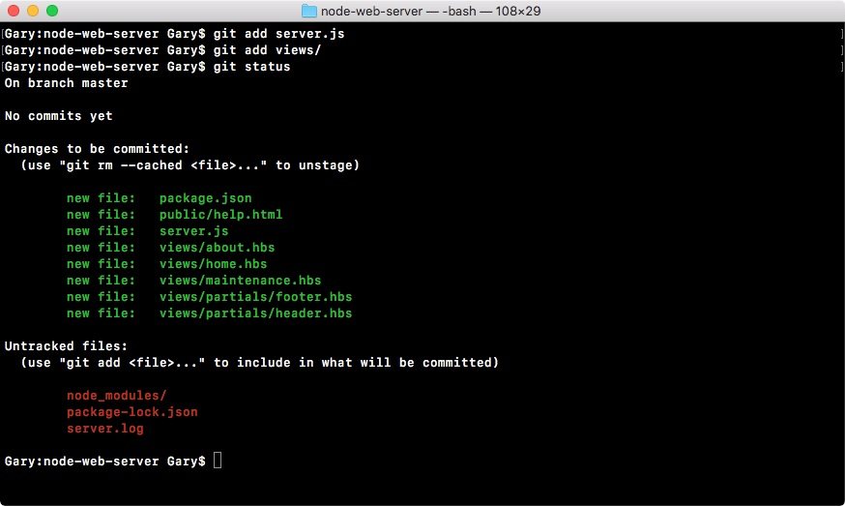

Everything looks good. Now the Untracked files are going to sit around here until we do one of two things—we either add them to the Git repository or ignore them using a custom file that we're going to create inside Atom.

Inside Atom, we'd like to make a new file called .gitignore, in our root of our project. The gitignore file is going to be part of our Git repository and it tells get which folders and files you want to ignore. In this case we can go ahead and ignore node_modules, just like this:

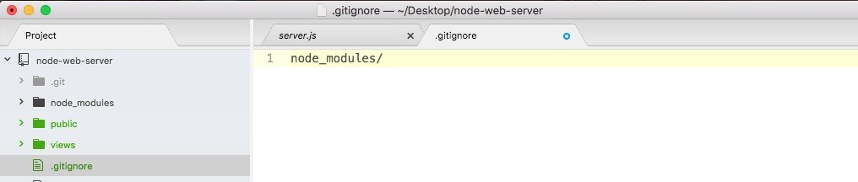

When we save the gitignore file and rerun git status from the Terminal, we'll now get a really different result:

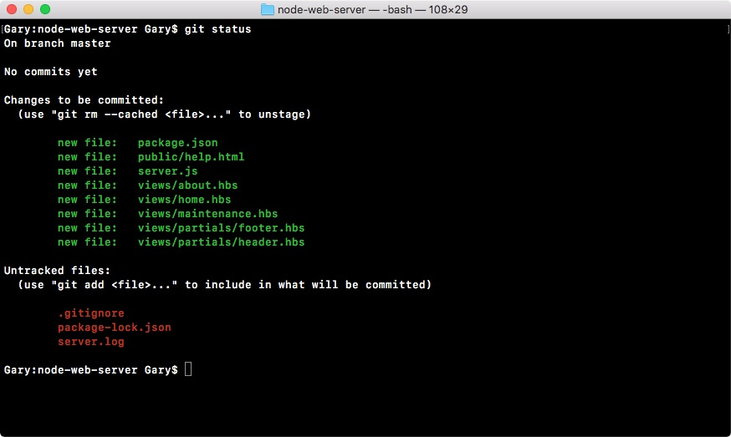

As shown, we can see we have a new untracked file—.gitignore—but the node_modules directory is nowhere in sight, and that's exactly what we want. We want to remove this completely, making sure that it never ever gets added to the Git repo. Next up, we can go ahead and ignore that server.log file by typing its name, server.log:

**node modules/ server.log**

We'll save gitignore, run git status from the Terminal one more time, and make sure everything looks great:

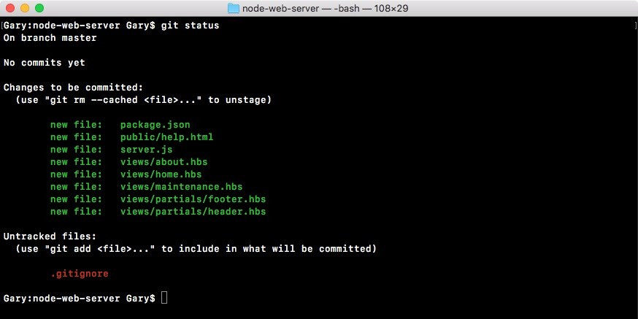

As shown, we have a gitignore file as our only untracked file. The server.log file and node_modules are nowhere in sight.

Now that we have gitignore, we are going to be adding it to Git using git add

.gitignore and when we run git status, we should be able to see that all the files that show up are under the initial commit:

**git add .gitignore git status**

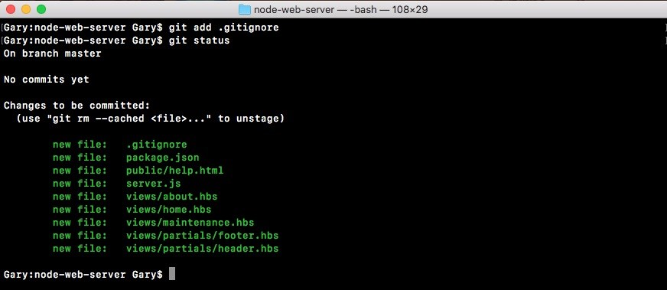

So now it's time to make a commit. A commit really only requires two things. It requires some change in the repository. In this case, we're teaching Git how to track a ton of new files, so we are indeed changing something, and it requires a message. We've already handled the file part of things. We've told Git what we want to save, we just haven't actually saved it yet.

**Making a commit**

In order to make our first commit and save our first thing into the Git repository, we'll run git commit and provide one flag, the m flag, which is short message. After that inside quotes, we can specify the message that we want to use for this commit. It's really important to use these messages so when someone's digging through the commit history, the list of all the changes to the project can be seen, which are actually useful. In this case, Initial commit is always a good message for your first commit: **git commit -m 'Initial commit'**

I'll go ahead and hit *enter* and as shown in the following screenshot, we see all of the changes that happened to the repo:

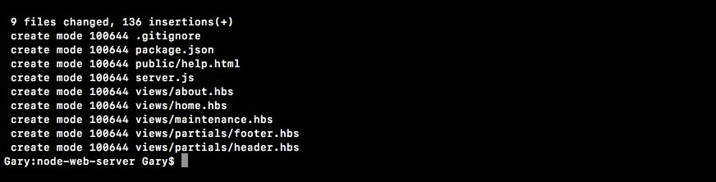

We have created a bunch of new files inside of the Git repository. These are all of the files that we told Git we want to keep track of and this is fantastic.

We now have our very first commit, which essentially means that we've saved the project at its current state. If we make a big change to server.js, messing stuff up to not be able figure out how to get it back to the way it was, we can always get it back because we made a Git commit. Now we'll explore some more fancy Git things in the later sections. We'll be talking about how to do most of the things you want to do with Git, including deploying to Heroku and pushing to GitHub.

**Setting up GitHub and SSH keys**

Now that you have a local Git repository, we'll look at how we can take that code and push it up to a third-party service called GitHub. GitHub is going to let us host our Git repositories remotely, so if our machine ever crashes we can get our code back, and it also has great collaboration tools, so we can open-source a project, letting others use our code, or we can keep it private so only people we choose to collaborate with can see the source code.

Now in order to actually communicate between our machine and GitHub, we'll have to create something called an SSH key. SSH keys were designed to securely communicate between two computers. In this case, it will be our machine and the GitHub server. This will let us confirm that GitHub is who they say they are and it will let GitHub confirm that we indeed have access to the code we're trying to alter. This will all be done with SSH keys and we'll create them first, then we'll configure them, and finally we'll push our code up to GitHub.

**Setting up SSH keys**

The process of setting up SSH keys can be a real burden. This is one of those topics where there's really small room for error. If you type any of the commands wrong, things are just not going to work as expected.

Now if you're on Windows, you'll need to do everything in this section from a Git Bash as opposed to the regular Command Prompt because we'll be using some commands that just are not available on Windows. They are, however, available on Linux and macOS. So if you're using either of those operating systems, you can continue using the Terminal you've been using throughout the book.

**SSH keys documentations**

Before we dive into the commands, I want to show you a quick guide that exists online in case you get stuck or you have any questions. You can Google GitHub SSH keys, and this is going to link you to an article called generating an SSH

key: <https://help.github.com/articles/connecting-to-github-with-ssh/>. Once you're here, you'll be able to click on the SSH breadcrumb, and this is going to bring you back to all of their articles on SSH keys:

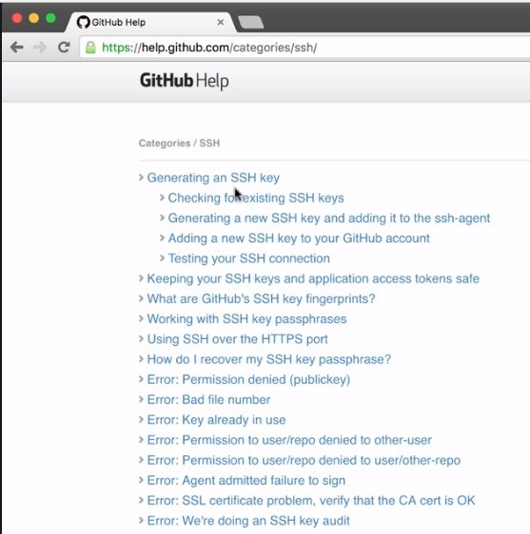

Out of these articles, the nested four are the ones we'll be focusing on checking if we have a key, generating a new key, adding the key to GitHub, and finally testing that everything worked as expected. If you run into any problems along any of these steps, you can always click on the guide for that step and you can pick the operating system you're using so you can see the appropriate commands for that OS. Now that you know this exists, let's go ahead and do it together.

**Working on commands**

The first command we'll run from the Terminal is going to check if we have an existing SSH key. Now if you don't, that's fine. We'll go ahead and create one. If you do or you're not sure you do, you can run the following command to confirm whether or not you have one: ls with the al flag. This is going to print all the files in a given directory, and the directory where SSH keys are stored by default on your machine is going to be at the user directory, which you can use (~) as a shortcut for /.ssh: **ls -al ~/.ssh**

When you run the command, you'll see all of the contents inside of that SSH directory:

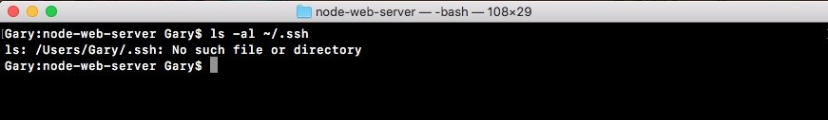

In this case I've deleted all of my SSH keys so I have nothing inside my directory. I just have paths for the current directory and the previous one. Now that we have this in place and we've confirmed we don't have a key, we can go ahead and generate one. If you do already have a key, a file like id_rsa, you can go ahead and skip the process of generating the key.

**Generating a key**

To make a key we'll use the ssh-keygen command. Now the ssh-keygen takes three arguments. We'll pass in t setting it equal to rsa. We'll pass in b which is for bytes, setting that equal to 4096. Make sure to match these arguments exactly, and we'll be setting a capital C flag which will get set equal to your email: **ssh-keygen -t rsa -b 4096 -C 'garyngreig@gmail.com'**



*Now the scope of what's actually happening behind the scenes is not part of this book. SSH keys and setting up security, that could be an entire course in and of itself. We'll be using this command to simplify the entire process.*

Now we can go ahead and hit *enter*, which will generate two new files in our .ssh folder. When you run this command, you'll get greeted with a few steps. I want you to use the default for all of them:

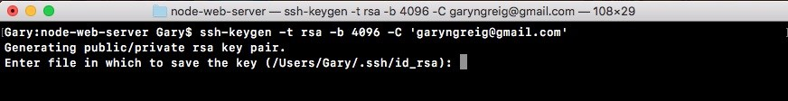

Here they want to ask you if you want to customize the file name. I do not recommend doing that. You can just hit *enter*:



Next up they ask you for a passphrase, which we'll not use. I'll hit *enter* for no passphrase, then I need to confirm the passphrase, so I'll just hit *enter* again:

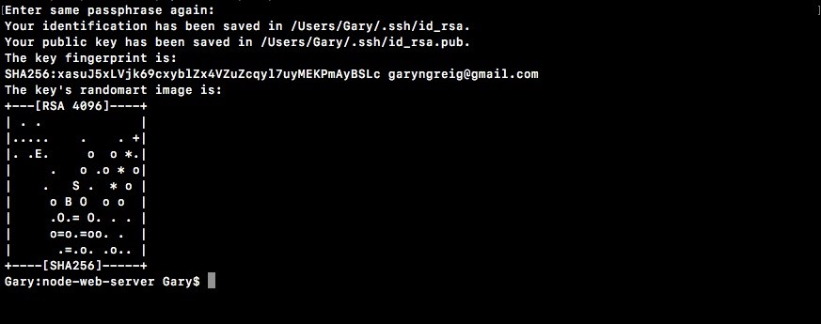

As shown, we get a little message that our SSH key was properly created and that it was indeed saved in our folder.

With this in place, I can now cycle back through my previous commands running the ls command, and what do I get?

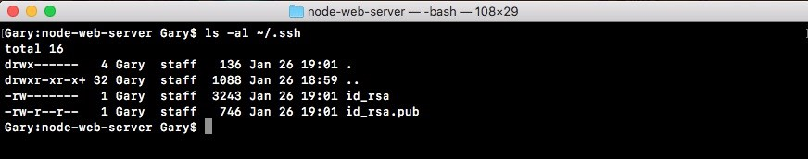

We get id_rsa and I get the id_rsa.pub file. The id_rsa file contains the private key. This is the key you should never give to anyone. It lives on your machine and your machine only. The .pub file, which is the public file. This one is the one you'll give to third-party services such as GitHub or Heroku, which we'll be doing in the next several sections.

**Starting up the SSH agent**

Now that our keys are generated, the last thing we need to do is start up the SSH agent and add this key so it knows that it exists. We'll do this by running two commands. These are:

eval ssh-add

First up we'll run eval, and then we'll open some quotes and inside the quotes, we'll use the dollar sign and open and close some parentheses just like this: **eval "$()"**

Inside our parentheses we'll type ssh-agent with the s flag: **eval "$(ssh-agent -s)"**

This will start up the SSH agent program and it will also print the process ID to confirm it is indeed running, and as shown, we get Agent pid 1116:



The process ID is obviously going to be different for everyone. As long as you get something back like this you are good to go.

Next up we have to tell the SSH agent where this file lives. We'll do that using ssh-add. This takes the path to our private key file which we have in the user directory /.ssh/id_rsa: **ssh-add ~/.ssh/id_rsa**

When I run this, I should get a message like identity added:



This means that the local machine now knows about this public/private key pair and it'll try to use these credentials when it communicates with a third-party service such as GitHub. Now that we have this in place, we are ready to configure GitHub. We'll make an account, set it up, and then we'll come back and test that things are working as expected.

**Configuring GitHub**

To configure GitHub, follow these steps:

1. First head into the browser and go to [github.com](https://github.com/).
2. Here log into your existing account or create a new one. If you need a new one, sign up for GitHub. If you have an existing one, go ahead and sign into it.
3. Once signed in, you should see the following screen. This is your GitHub dashboard:

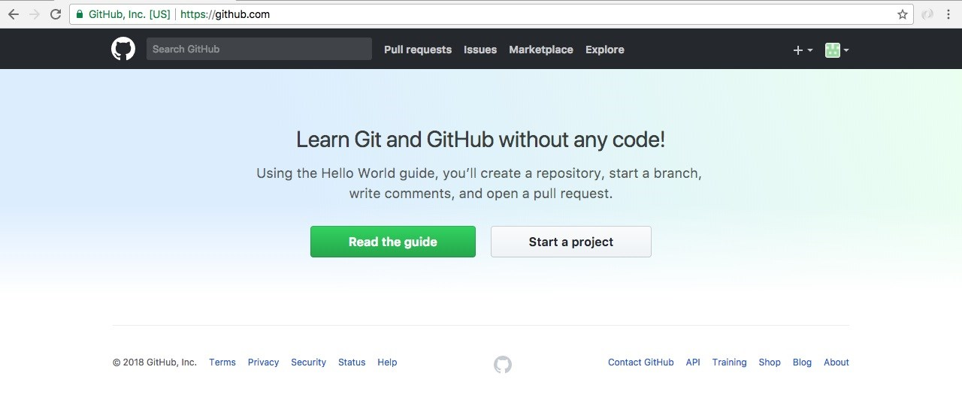

1. From here, navigate to Settings, present at the top-left hand side, by the profile picture. Go to Settings | SSH and GPG keys | SSH keys:

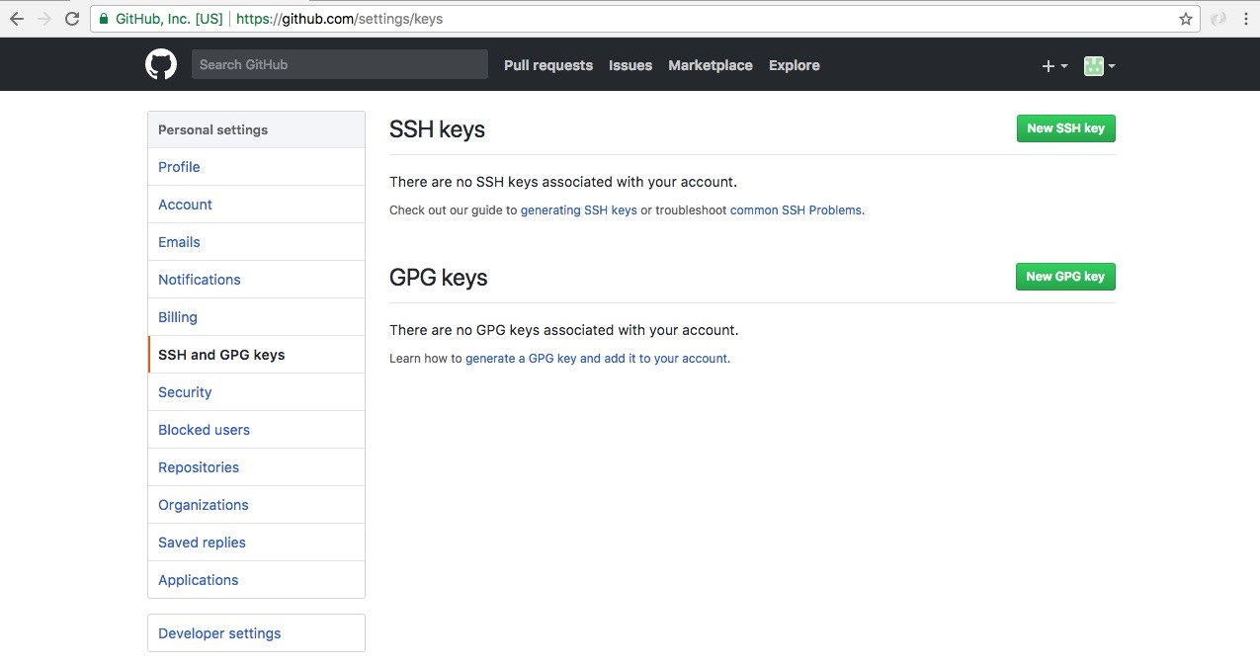

1. From here we can add the public key, letting GitHub know that we want to communicate using SSH.
2. Add the new SSH key:

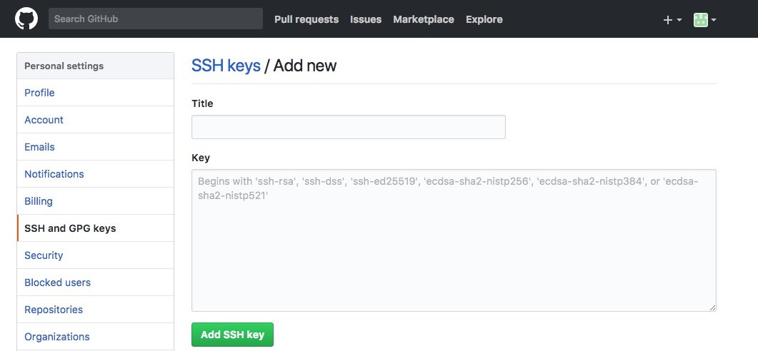

Here, you need to do two things: give it a name, and add the key.

First add the name. The name can be anything you like. For example, I usually use one that uniquely identifies my computer since I have a couple. I'll use MacBook Pro, just like this.



Next up, add the key.

To add the key, we need to grab the contents of the id_rsa.pub file, we generated in the previous sub-section. That file contains the information that GitHub needs in order to securely communicate between our machine and their machines. There are different methods to grab the key. In the browser, we have the Adding a new SSH key to your GitHub account article for our reference.

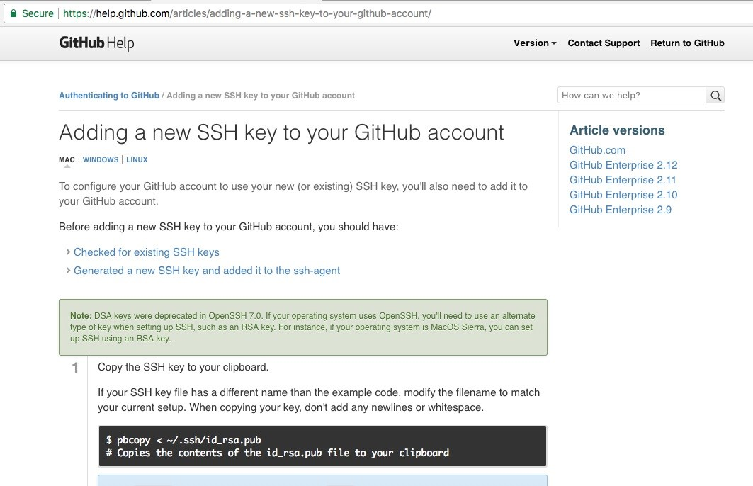

1. This contains a command you can use to copy the contents of that file to your clipboard from right inside the Terminal. Now obviously it is different for the operating systems, macOS, Windows, and Linux, so run the command for your operating system.
2. Use the pbcopy command which is available for macOS.

Then, move into the Terminal and run it.

**pbcopy < ~/.ssh/id_rsa.pub**

This copies the contents of the file to the clipboard. You can also open the command up with a regular text editor and copy the contents of the file. We can use any method to copy the file. It doesn't matter how you do it. All that matters is you do.

1. Now move back into GitHub, click on the text area and paste it in.

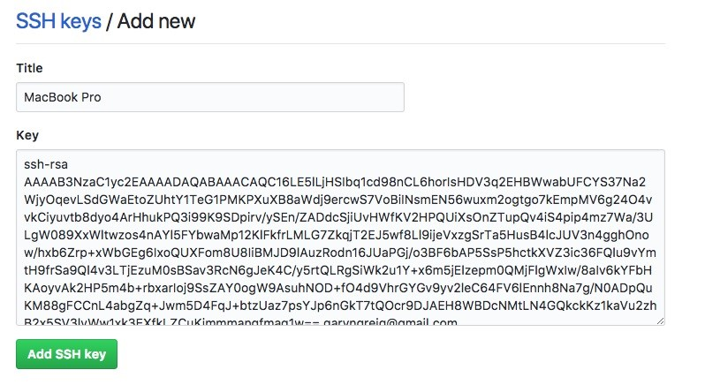

The contents of id_rsa.pub should start with ssh-rsa and it should end with that email you used.

1. Once you're done, go ahead and click on Add SSH key.

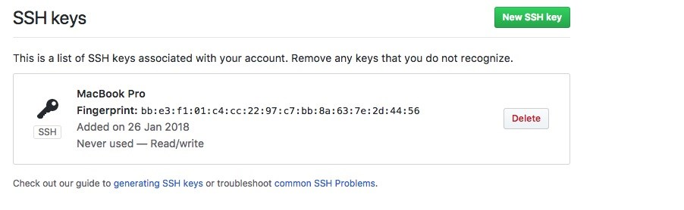

Now we can go ahead and test that things are working by running one command from the Terminal. Once again this command can be executed from anywhere on your machine. You don't need to be in your project folder to do this.

**Testing the configuration**

To test the working of our GitHub configuration, we'll use ssh, which tries to make a connection. We'll use the T flag, followed by the URL we want to connect to you get at git@github.com: **ssh -T git@github.com**

This is going to test our connection. It will make sure that the SSH keys are properly set up and we can securely communicate with GitHub. When I run the command I get a message saying that The authenticity of host 'github.com (192.30.253.113)' can't be established.

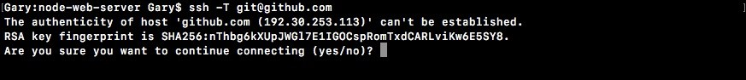

We know that we want to communicate with [github.com](http://www.github.com/). We're expecting that communication to happen, so we can go ahead and enter yes:



From here, we get a message from the GitHub servers as shown in the preceding screenshot. If you are seeing this message with your username then you are done. You're ready to create your first repository and push your code up.

*Now if you don't see this message, something went wrong along the way. Maybe the SSH key wasn't generated correctly or it's not getting recognized by GitHub.*

Next, we'll move into GitHub, go back to the home page, and create a new repository.

**Creating a new repository**

To create a new repository, follow these steps:

1. On the GitHub home page, in the right-hand side corner, navigate to the New repository button, which should look like this (click on Start New Project if it's a new one):

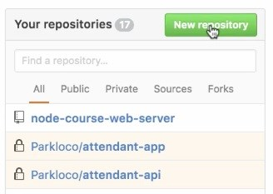

This will lead us to the new repository page:

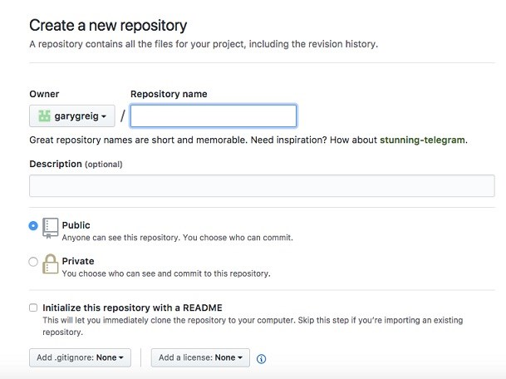

1. Here, all we need to do is give it a name. I'm going to call this one node-

course-2-web-server:

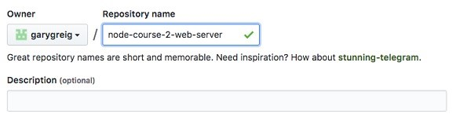

Once you have a name, you could give it an optional description and you can pick whether you want to go with a public or private repository.

*Now private repositories do put you on a $7 plan. I do recommend that if you're creating projects with other companies.*

1. In this case though, we're creating pretty simple projects and it doesn't really matter if someone else finds the code, so go ahead and use a public repository by clicking that option.



1. Once you have those two things filled out, click on the Create repository button:

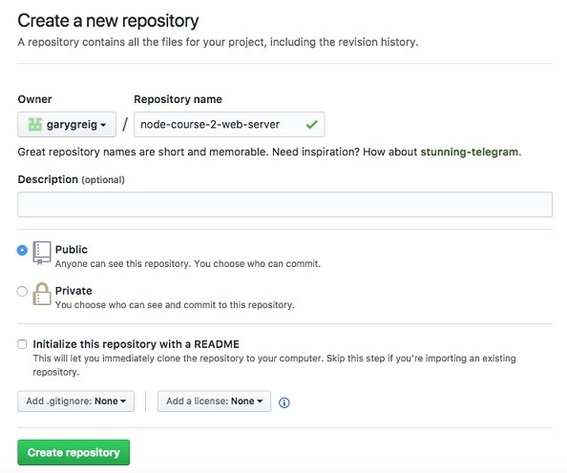

This is going to get brought to your repository page:

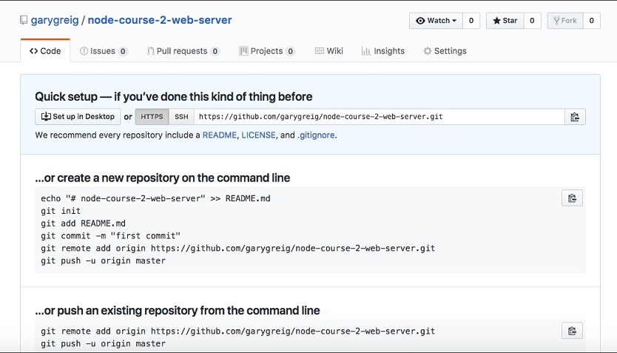

It will give you a little setup because currently there is no code to view, so it will give you a few instructions depending on which situation you're in.

**Setting up the repository**

Now, out of the preceding three setup instructions, we don't need the one for creating a new repository. We are not going to use the one for importing our code from some other URL. What we have is an existing repository and we want to push it from the command line.

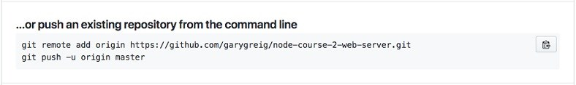

We'll run these two commands from inside our project:

The first one adds a new remote to our Git repository

The second command is going to push it up to GitHub

Remotes let Git know which third-party URLs you want to sync up with. Maybe I want to push my code to GitHub to communicate with my co-workers. Maybe I also want to be able to push up to Heroku to deploy my app. That means you would want two remotes. In our case, we'll just add one, so I'll copy this URL, move into the Terminal, paste it, and hit *enter*: **git remote add origin https://github.com/garygreig/node-course-2-web-server.git**

Now that we have our git remote added, we can go ahead and run that second command. We'll use the second command extensively throughout the book. In the Terminal, we can copy and paste the code for second command, and run it:

**git push -u origin master**

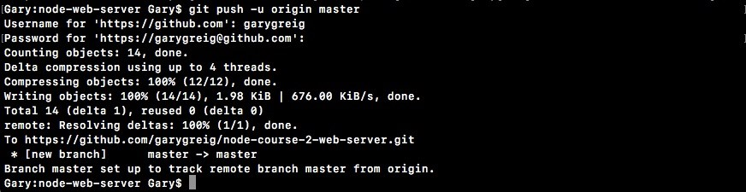

As shown in the preceding screenshot, we can see everything went great. We were able to successfully write all of our data up to GitHub, and if we go back into the browser and refresh the page, we're no longer going to see those setup instructions. Instead, we're going to see our repository, kind of like a tree view:

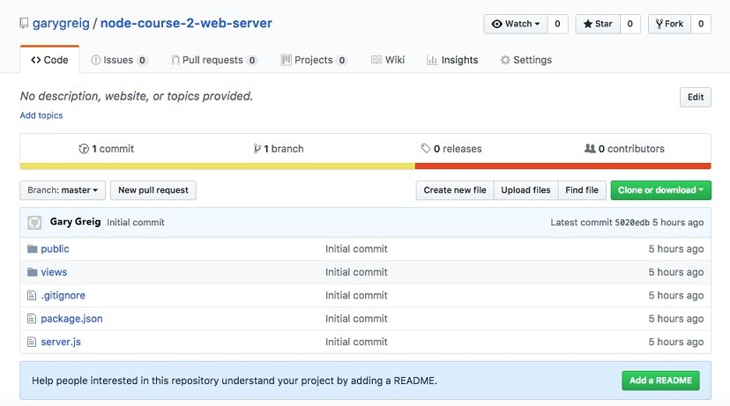

Here we can see we have our server.js file, which is great. We don't see the log file or node_module file, which is good, because we ignored that. I have my public directory. Everything works really really well. We also have issues tracking, Pull requests. You can create a Wiki page which lets you set up instructions for your repository. There's a lot of really great features that GitHub has to offer. We'll be using just the very basic features.

On our repository, we can see we have one commit and if we click on that one commit button, you can actually go to the commits page and here we see the initial commit message that we typed. We made that commit in the previous section:

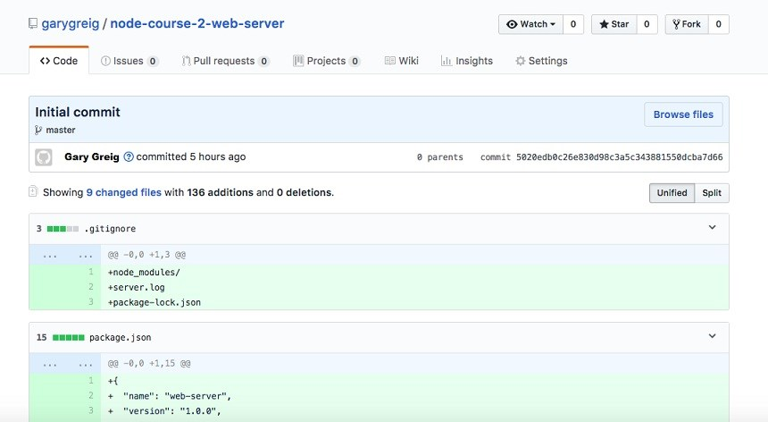

This is going to let us keep track of all our code, revert if we make unwanted changes, and manage our repository. Now that we have our code pushed up, we are done.

**Deploying the node app to the Web**

In this section, you'll deploy your Node app live to the Web using Heroku. By the end of the section, you'll have the URL you can give anybody and they'll be able to go to that URL in their browser to view the application. We'll do this via Heroku.

Heroku is a website. It's a web app for managing web applications that are hosted in the cloud. It's a really great service. They make it almost effortless to create new apps, deploy your apps, update apps, and add cool add-on-things such as logging and error tracking, all of that is built in. Now Heroku, like GitHub, does not require a credit card to sign up and there is a free tier, which we'll use. They have paid plans for just about everything, but we can get away with the free tier for everything we'll do in this section.

**Installing Heroku command-line tools**

To kick things off, we'll open up the browser and go to [heroku.com](https://www.heroku.com/). Here we can go ahead and sign up for a new account. Take a quick moment to either log in to your existing one or sign up for a new one. Once log in, it'll show you the dashboard. Now your dashboard will look something like this:

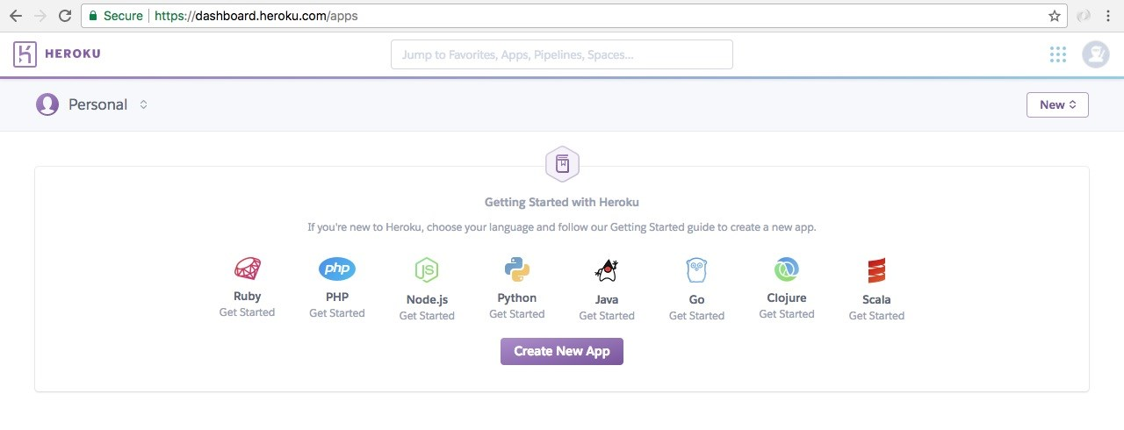

Although there might be a greeting telling you to create a new application, which you can ignore. I have a bunch of apps. You might not have these. That is perfectly fine.

The next thing we'll do is install the Heroku command-line tools. This will let us create apps, deploy apps, open apps, and do all sorts of really cool stuff from the Terminal, without having to come into the web app. That will save us time and [make development a lot easier. We can grab the download by going to toolbelt.he](https://devcenter.heroku.com/articles/heroku-cli)

[roku.com.](https://devcenter.heroku.com/articles/heroku-cli)

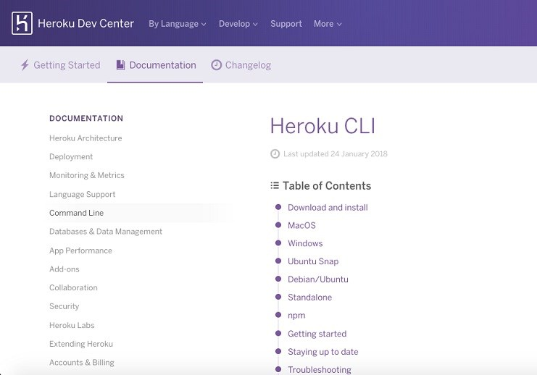

Here we're able to grab the installer for whatever operating system, you happen to be running on. So, let's start the download. It's a really small download so it should happen pretty quickly.

Once it's done, we can go ahead and run through the process:

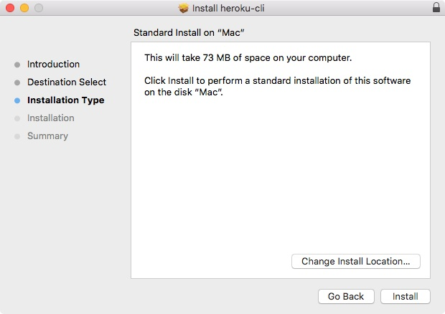

This is a simple installer where you just click on Install. There is no need to customize anything. You don't have to enter any specific information about your Heroku account. Let's go ahead and complete the installer.

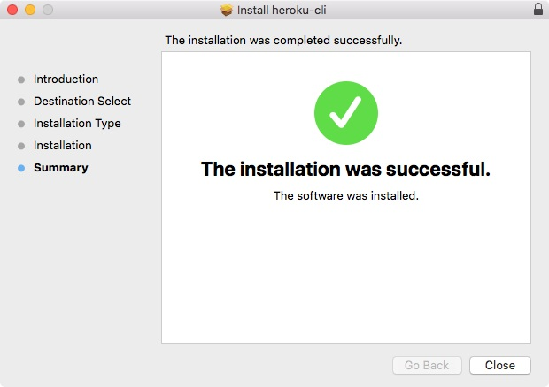

This will give us a new command from the Terminal that we can execute. Before we can do that, we do have to log in locally in the Terminal and that's exactly what we'll do next.

**Log in to Heroku account locally**

Now we will start off the Terminal. If you already have it running, you might need to restart it in order for your operating system to recognize the new command. You can test that it got installed properly by running the following command:

**heroku --help**

When you run this command, you'll see that it's installing the CLI for the first time and then we'll get all the help information. This will tell us what commands we have access to and exactly how they work:

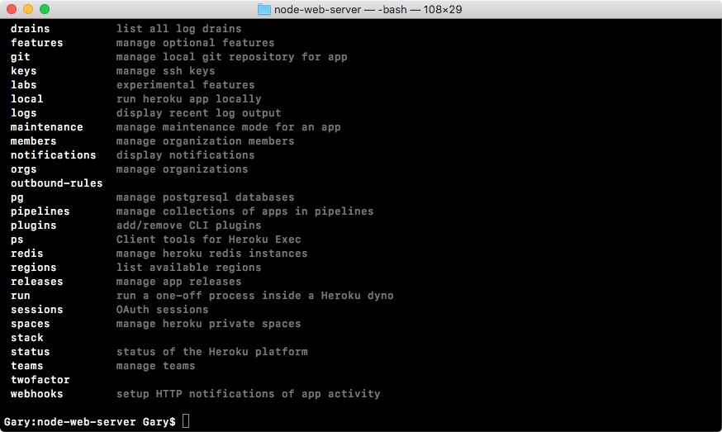

Now we will need to log in to the Heroku account locally. This process is pretty simple. In the preceding code output, we have all of the commands available and one of them happens to be login. We can run heroku login just like this to start the process: **heroku login**

I'll run the login command and now we just use the email and password that we had set up before:

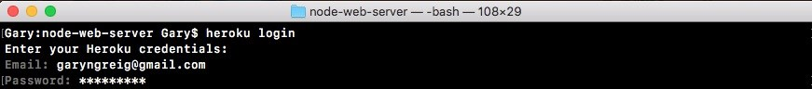

I'll type in my email and password. Typing for Password is hidden because it's secure. And when I do that you see Logged in as garyngreig@gmail.com shows up and this is fantastic:



Now we're logged in and we're able to successfully communicate between our machine's command line and the Heroku servers. This means we can get started creating and deploying applications.

**Getting SSH key to Heroku**

Now before going ahead, we'll use the clear command to clear the Terminal output and get our SSH key on Heroku, kind of like what we did with GitHub, only this time we can do it via the command line. So it's going to be a lot easier.

In order to add our local keys to Heroku, we'll run the heroku keys:add command. This will scan our SSH directory and add the key up: **heroku keys:add**

Here you can see it found a key the id_rsa.pub file: Would you like to upload it to Heroku?.



Type Yes and hit *enter*:



Now we have our key uploaded. That is all it took. Much easier than it was to configure with GitHub. From here, we can use the heroku keys command to print all the keys currently on our account:

**heroku keys**



We could always remove them using

heroku keys:remove

command followed by the

email related to that key. In this case, we'll keep the Heroku key that we have.

Next up, we can test our connection using SSH with the v flag and git@heroku.com:

**ssh -v git@heroku.com**

This will communicate with the Heroku servers:

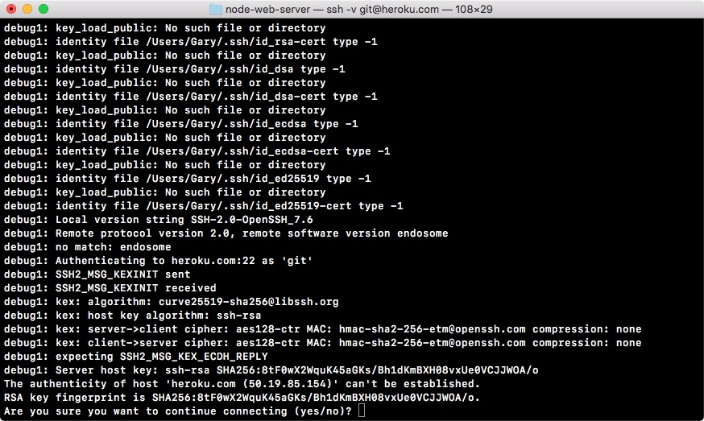

As shown, we can see it's asking that same question: The authenticity of the host 'heroku.com' can't be established, Are you sure you want to continue connecting?

Type Yes.

You will see the following output:

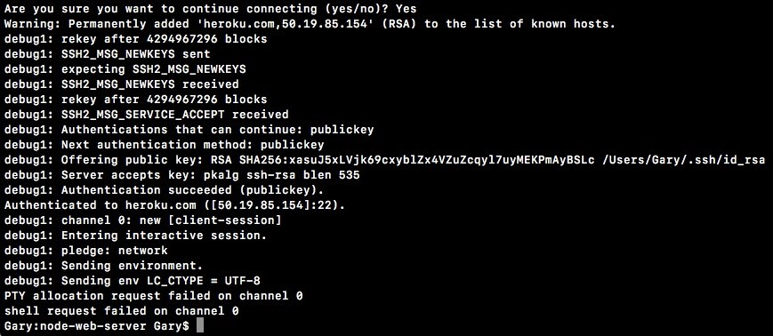

Now when you run that command, you'll get a lot of cryptic output. What you're looking for is authentication succeeded and then public key in parentheses. If things did not go well, you'll see the permission denied message with public key in parentheses. In this case, the authentication was successful, which means we are good to go. I'll run clear again, clearing the Terminal output.

**Setting up in the application code for Heroku**

Now we can turn our attention towards the application code because before we can deploy to Heroku, we will need to make two changes to the code. These are things that Heroku expects your app to have in place in order to run properly because Heroku does a lot of things automatically, which means you have to have some basic stuff set up for Heroku to work. It's not too complex—some really simple changes, a couple one-liners.

**Changes in the server.js file**

First up in the server.js file down at the very bottom of the file, we have the port and our app.listen statically coded inside server.js:

app.listen(3000, () => { console.log('Server is up on port 3000'); });

We need to make this port dynamic, which means we want to use a variable. We'll be using an environment variable that Heroku is going to set. Heroku will tell your app which port to use because that port will change as you deploy your app, which means that we'll be using that environment variable so we don't have to swap out our code every time we want to deploy.

With environment variables, Heroku can set a variable on the operating system. Your Node app can read that variable and it can use it as the port. Now all machines have environment variables. You can actually view the ones on your machine by running the env command on Linux or macOS or the set command on Windows.

What you'll get when you do that is a really long list of key-value pairs, and this is all environment variables are:

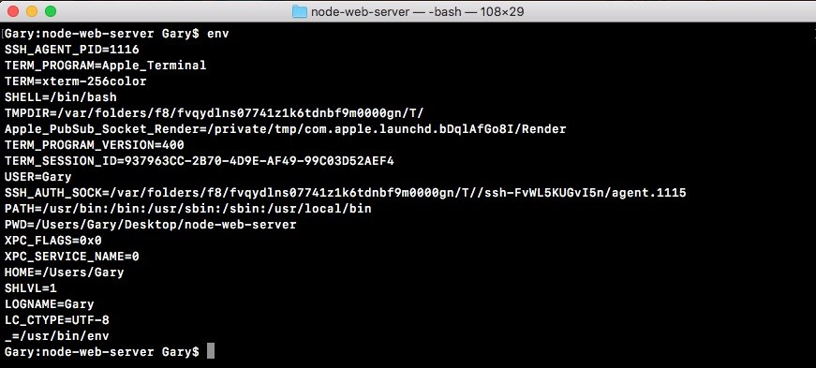

Here, we have a LOGNAME environment variable set to Andrew. I have a HOME environment variable set to my home directory, all sorts of environment variables throughout my operating system.

One of these that Heroku is going to set is called PORT, which means we need to go ahead and grab that port variable and use it in server.js instead of 3000. Up at the very top of the server.js file, we'd to make a constant called port, and this will store the port that we'll use for the app:

const express = require('express');.

const hbs = require('hbs'); const fs = require('fs'); **const port**

Now the first thing we'll do is grab a port from process.env. The process.env is an object that stores all our environment variables as key-value pairs. We're looking for one that Heroku is going to set called PORT: const port = process.env.PORT;

This is going to work great for Heroku, but when we run the app locally, the PORT environment variable is not going to exist, so we'll set a default using the OR (||) operator in this statement. If process.env.port does not exist, we'll set port equal to 3000 instead: const port = process.env.PORT || 3000;

Now we have an app that's configured to work with Heroku and to still run locally, just like it did before. All we have to do is take the PORT variable and use that in app.listen instead of 3000. As shown, I'm going to reference port and inside our message, I'll swap it out for template strings and now I can replace 3000 with the injected port variable, which will change over time:

app.listen(port, () => { console.log(`Server is up on port ${port}`); });

With this in place, we have now fixed the first problem with our app. I'll now run node server.js from the Terminal, like we did in the previous chapter: **node server.js**

We still get the exact same message: Server is up on port 3000, so your app will still works locally as expected:

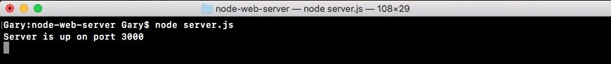

**Changes in the package.json file**

Next up, we have to specify a script in package.json. Inside package.json, you might have noticed we have a scripts object, and in there we have a test script.

This gets set by default for npm:

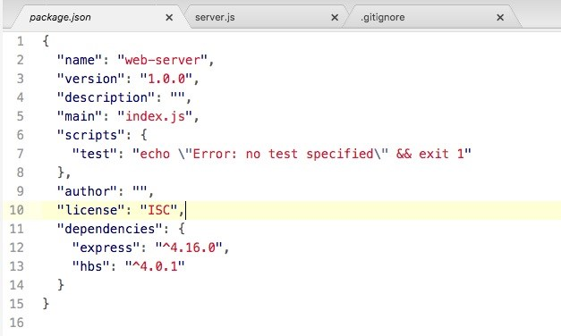

We can create all sorts of scripts inside the scripts object that do whatever we like. A script is nothing more than a command that we run from the Terminal, so we could take this command, node server.js, and turn it into a script instead, and that's exactly what we're going to do.

Inside the scripts object, we'll add a new script. The script needs to be called start:



This is a very specific, built-in script and we'll set it equal to the command that starts our app. In this case, it will be node server.js:

"start": "node server.js"

This is necessary because when Heroku tries to start our app, it will not run Node with your file name because it doesn't know what your file name is called. Instead, it will run the start script and the start script will be responsible for doing the proper thing; in this case, booting up that server file.

Now we can run our app using that start script from the Terminal by using the following command:

**npm start**

When I do that, we get a little output related to npm and then we get Server is up on port 3000, and if we visit the app in the browser, everything works exactly as it did in the previous chapter:

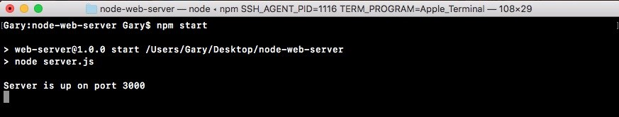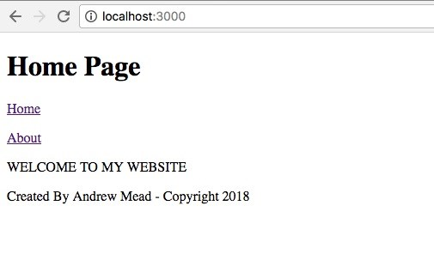

The big difference is that we are now ready for Heroku. We could also run the test script using from the Terminal npm test: **npm test**

Now, we have no tests specified and that is expected:

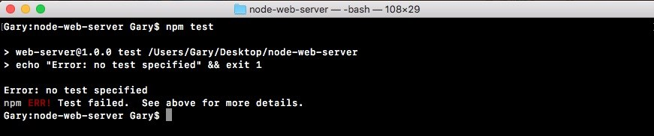

**Making a commit in Heroku**

The next step in the process will be to make the commit and then we can finally start getting it up on the Web. From the Terminal, we'll use some of the Git commands we explored earlier in this chapter. First up, git status. When we run git status, we have something a little new:

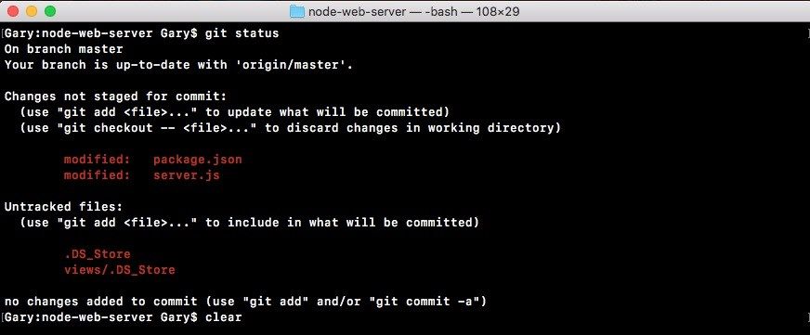

Instead of new files, we have modified files here as shown in the code output here. We have a modified package.json file and we have a modified server.js file. These are not going to be committed if we were to run a git commit just yet; we still have to use git add. What we'll do is run git add with the dot as the next argument. Dot is going to add every single thing showing up and get status to the next commit.

Now I only recommend using the syntax of everything you have listed in the Changes not staged for commit header. These are the things you actually want to commit, and in our case, that is indeed what we want. If I run git add and then a rerun git status, we can now see what is going to be committed next, under the Changes to be committed header:

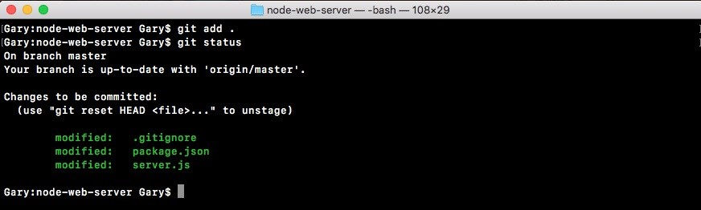

Here we have our package.json file and the server.js file. Now we can go ahead and make that commit.

I'll run a git commit command with the m flag so we can specify our message, and a good message for this commit would be something like Setup start script and heroku port: **git commit -m 'Setup start script and heroku port'**

Now we can go ahead and run that command, which will make the commit.

Now we can go ahead and push that up to GitHub using the git push command, and we can leave off the origin remote because the origin is the default remote. I'll go ahead and run the following command: **git push**

This will push it up to GitHub, and now we are ready to actually create the app, push our code up, and view it over in the browser:

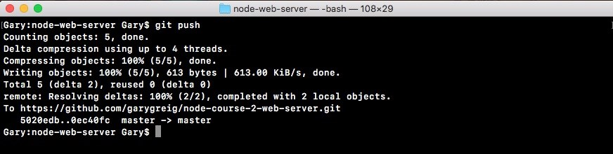

**Running the Heroku create command**

The next step in the process will be to run a command called heroku create from the Terminal. heroku create needs to get executed from inside your application: **heroku create**

Just like we run our Git commands, when I run heroku create, a couple things are going to happen:

First up, it's going to make a real new application over in the Heroku web app

It's also going to add a new remote to your Git repository

Now remember we have an origin remote, which points to our GitHub repository. We'll have a Heroku remote, which points to our Heroku Git repository. When we deploy to the Heroku Git repository, Heroku is going to see that. It will take the changes and it will deploy them to the Web. When we run Heroku create, all of that happens:

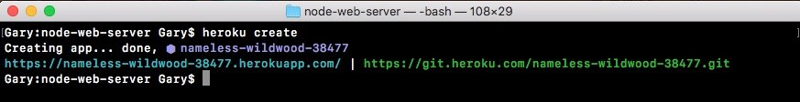

Now we do still have to push up to this URL in order to actually do the deploying process, and we can do that using git push followed by heroku: **git push heroku**

The brand new remote was just added because we ran heroku create. Now pushing it this time around will go through the normal process. You'll then start seeing some logs.

These are logs coming back from Heroku letting you know how your app is deploying. It's going through the entire process, showing you what happens along the way. This will take about 10 seconds and at the very end we have a success message—Verifying deploy... done:

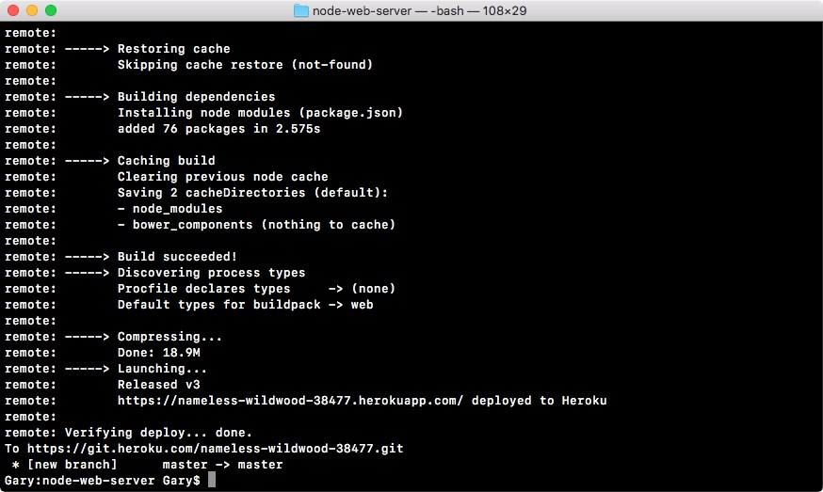

It also verified that the app was deployed successfully and that did indeed pass.

[From here we actually have a URL we can visit (https://sleepy-retreat-32096.heroku app.com/). We can take it, copy it, and paste it in the browser. What I'll do instead](https://sleepy-retreat-32096.herokuapp.com/) is use the following command: **heroku open**

The heroku open will open up the Heroku app in the default browser. When I run this, it will switch over to Chrome and we get our application showing up just as expected:

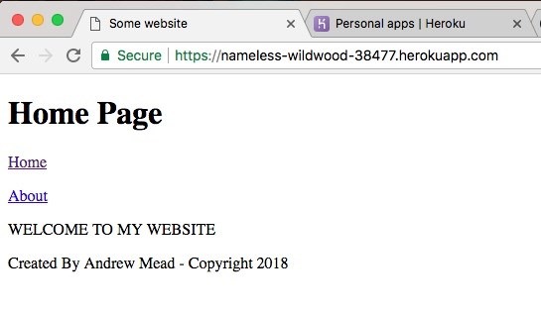

We can switch between pages and everything works just like it did locally. Now we have a URL and this URL was given to us by Heroku. This is the default way Heroku generates app URLs. If you have your own domain registration company, you can go ahead and configure its DNS to point to this application. This will let you use a custom URL for your Heroku app. You'll have to refer to the specific instructions for your domain registrar in order to do that, but it can indeed be done.

Now that we have this in place, we have successfully deployed our Node applications live to Heroku, and this is just fantastic. In order to do this, all we had to do is make a commit to change our code and push it up to a new Git remote. It could not be easier to deploy our code.

You can also manage your application by going back over to the Heroku dashboard. If you give it a refresh, you should see that brand new URL somewhere on the dashboard. Remember mine was sleepy retreat. Yours is going to be something else. If I click on the sleepy retreat, I can view the app page:

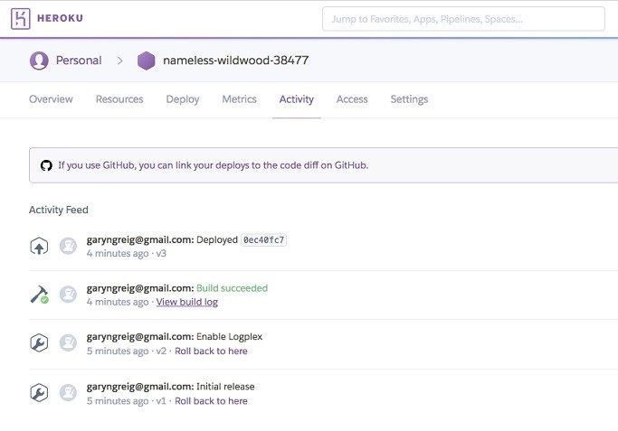

Here we can do a lot of configuration. We can manage Activity and Access so we can collaborate with others. We have metrics, we have Resources, all sorts of really cool stuff. With this in place, we are now done with our basic deploying section.

In the next section, your challenge will be to go through that process again. You'll add some changes to the Node app. You'll commit them, deploy them, and view them live in the Web. We'll get started by creating the local changes. That means I'll register a new URL right here using app.get.

We'll create a new page/projects, which is why I have that as the route for my HTTP get handler. Inside the second argument, we can specify our callback function, which will get called with request and response, and like we do for the other routes above, the root route and our about route, we'll be calling response.render to render our template. Inside the render arguments list, we'll provide two.

The first one will be the file name. The file doesn't exist, but we can still go ahead and call render. I'll call it projects.hbs, then we can specify the options we want to pass to the template. In this case, we'll set page title, setting it equal to Projects with a capital P. Excellent! Now with this in place, the server file is all done. There are no more changes there.

What I'll do is go ahead and go to the views directory, creating a new file called projects.hbs. In here, we'll be able to configure our template. To kick things off, I'm going to copy the template from the about page. Since it's really similar, I'll copy it. Close about, paste it into projects, and I'm just going to change this text to project page text would go here. Then we can save the file and make our last change.

The last thing we want to do is update the header. We now have a brand new projects page that lives at /projects. So we'll want to go ahead and add that to the header links list. Right here, I'll create a new paragraph tag and then I'll make an anchor tag. The text for the link will be Projects with a capital P and the href, which is the URL to visit when that link is clicked. We'll set that equal to /projects, just like we did for about, where we set it equal to /about.

Now that we have this in place, all our changes are done and we are ready to test things out locally. I'll fire up the app locally using Node with server.js as the file. To start, we're up on localhost 3000. So over in the browser, I can move to the localhost tab, as opposed to the Heroku app tab, and click on Refresh. Right here we have Home, which goes to home, we have About which goes to about, and we have Projects which does indeed go to /projects, rendering the projects page. Project page text would go here. With this in place we're now done locally.

We have the changes, we've tested them, now it's time to go ahead and make that commit. That will happen over inside the Terminal. I'll shut down the server and run Git status. This will show me all the changes to my repository as of the last commit. I have two modified files: the server file and the header file, and I have my brand new projects file. All of this looks great. I want to add all of this to the next commit, so I can use a Git add with the . to do just that.

Now before I actually make the commit, I do like to test that the proper things got added by running Git status. Right here I can see my changes to be committed are showing up in green. Everything looks great. Next up, we'll run a Git commit to actually make the commit. This is going to save all of the changes into the Git repository. A message for this one would be something like adding a project page.

With a commit made, the next thing you needed to do was push it up to GitHub. This will back our code up and let others collaborate on it. I'll use Git push to do just that. Remember we can leave off the origin remote as origin is the default remote, so if you leave off a remote it'll just use that anyway.

With our GitHub repository updated, the last thing to do is deploy to Heroku and we do that by pushing up the Git repository, using Git push, to the Heroku remote. When we do this, we get our long list of logs as the Heroku server goes through the process of installing our npm modules, building the app, and actually deploying it. Once it's done, we'll get brought back to the Terminal like we are here, and then we can open up the URL in the browser. Now I can copy it from here or run Heroku open. Since I already have a tab open with the URL in place, I'll simply give it a refresh. Now you might have a little delay as you refresh your app. Sometimes starting up the app right after a new app was deployed can take about 10 to 15 seconds. That will only happen as you first visit it. Other times where you click on the Refresh button, it should reload instantly.

Now we have the projects page and if I visit it, everything looks awesome. The navbar is working great and the projects page is indeed rendering at /projects. With this in place, we are now done. We've gone through the process of adding a new feature, testing it locally, making a Git commit, pushing it up to GitHub, and deploying it to Heroku. We now have a workflow for building real-world web applications using Node.js. This also brings a close to this section.

**Summary**

You also learned about Git, GitHub, and Heroku. These are the tools I prefer to use when I'm creating applications. I like to use Git because it's super popular. It's basically the only choice these days. I like to use GitHub because it has a great user interface. It has a ton of awesome features and pretty much everyone else is using it too. There's a great community. And I like to use Heroku because it is just dead simple to deploy new versions of your application. You can swap out any of these tools with any other tools. You can use services such Amazon Web Services to host. You could use Bitbucket as your GitHub alternative. These are perfectly fine solutions. All that really matters is you have some tools that are working for you, you have a Git repository backed up somewhere, whether it's GitHub or Bitbucket, and you have an easy way to deploy so you can make changes quickly and get them out to your users fast.

In different sections, we looked at how to add files to Git and how to make that first commit. Next, we set up both GitHub and Heroku, then we looked at how to push our code and deploy it. Then, we looked at how we can communicate with Heroku to deploy our code. Then after that, we looked at some real-world workflows for creating new commits, pushing to GitHub, and deploying to Heroku.

In the next chapter, we'll look into testing our applications.

**Testing the Node Applications – Part 1**

In this chapter, we'll look at how we can test our code to make sure it's working as expected. Now, if you've ever set up test cases for other languages, then you know how hard it can be to get started. You have to set up the actual test infrastructure. Then you have to write your individual test cases. Every time I didn't test an application, it was because the setup process and the tools available to me were such a burden. Then you dig around for information online and you get really simple examples, but not examples for testing real-world things like asynchronous code. We'll be doing all of that in this chapter. I'll give you a very simple setup for testing and writing your test cases.

We'll look at the best tools available so you'll actually be excited to write those test cases and see all of those green checkmarks. We'll be testing from here on out as well, so let's dive in looking at how we can test some code.

**Basic testing**

In this section, you'll create your very first test case so that you can test whether your code is working as expected. By adding automatic testing to our project, we'll be able to verify that a function does what it says it'll do. If we make a function that's supposed to add two numbers together, we can automatically verify it's doing that. And if we have a function that's supposed to fetch a user from the database, we can make sure it's doing that as well.

Now to get started in this section, we'll look at the very basics of setting up a testing suite inside a Node.js project. We'll be testing a real-world function.

**Installing the testing module**

In order to get started, we will make a directory to store our code for this chapter. We'll make one on the desktop using mkdir and we'll call this directory node-tests: **mkdir node-tests**

Then we'll change directory inside it using cd, so we can go ahead and run npm

init

. We'll be installing modules and this will require a

package.json

file:

**cd node-tests**

**npm init**

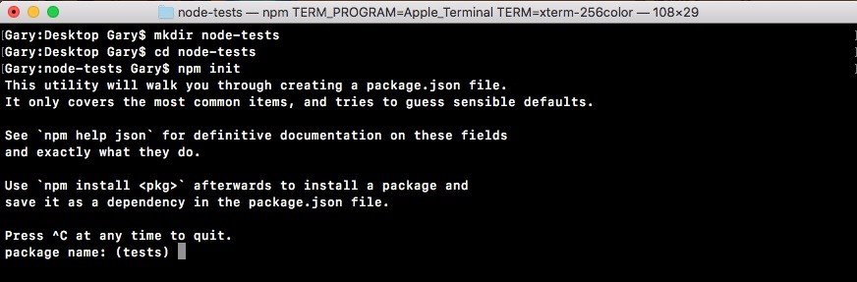

We'll run

npm init

using the default values for everything, simply hitting

*e*

*nter*

throughout every single step:

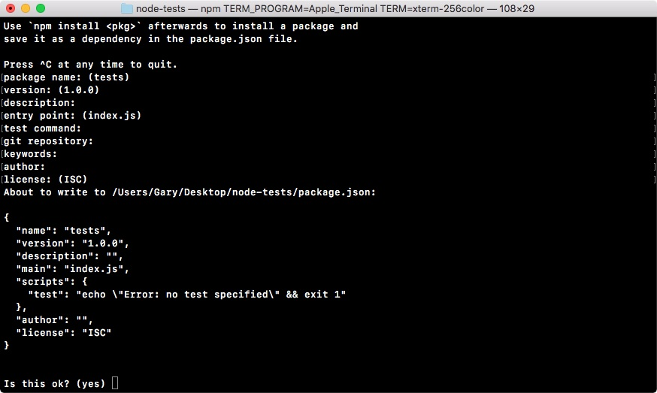

Now once that package.json file is generated, we can open up the directory inside Atom. It's on the desktop and it's called node-tests.

From here, we're ready to actually define a function we want to test. The goal in this section is to learn how to set up testing for a Node project, so the actual functions we'll be testing are going to be pretty trivial, but it will help illustrate exactly how to set up our tests.

**Testing a Node project**

To get started, let's make a fake module. This module will have some functions and we'll test those functions. In the root of the project, we'll create a brand new directory and I'll call this directory utils:

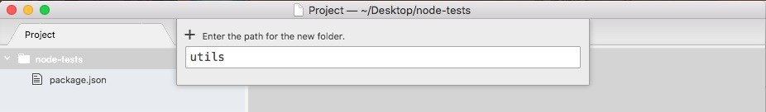

We can assume this will store some utility functions, such as adding a number to another number, or stripping out whitespaces from a string, anything kind of hodge-podge that doesn't really belong to any specific location. We'll make a new file in the utils folder called utils.js, and this is a similar pattern to what we did when we created the weather and location directories in our weather app in the previous chapter:

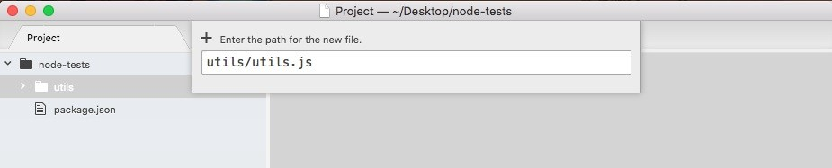

You're probably wondering why we have a folder and a file with the same name. This will be clear when we start testing.

Now before we can write our first test case to make sure something works, we need something to test. I'll make a very basic function that takes two numbers and adds them together. We'll create an adder function as shown in the following code block:

module.exports.add = () => {

}

This arrow function (=>) will take two arguments, a and b, and inside the function, we'll return the value a + b. Nothing too complex here:

module.exports.add = () => { return a + b; };

Now since we just have one expression inside our arrow function (=>) and we want to return it, we can actually use the arrow function (=>) expression syntax, which lets us add our expression as shown in the following code, a + b, and it'll be implicitly returned: module.exports.add = (a, b) => a + b;

There's no need to explicitly add a return keyword on to the function. Now that we have utils.js ready to go, let's explore testing.

We'll be using a framework called Mocha in order to set up our test suite. This will let us configure our individual test cases and also run all of our test files. This will be really important for creating and running tests. The goal here is to make testing simple and we'll use Mocha to do just that. Now that we have a file and a function we actually want to test, let's explore how to create and run a test suite.

**Mocha – the testing framework**

We'll be doing the testing using the super popular testing framework Mocha, which you can find at [mochajs.org](https://mochajs.org/). This is a fantastic framework for creating and running test suites. It's super popular and their page has all the information you'd ever want to know about setting it up, configuring it, and all the cool bells and whistles it has included:

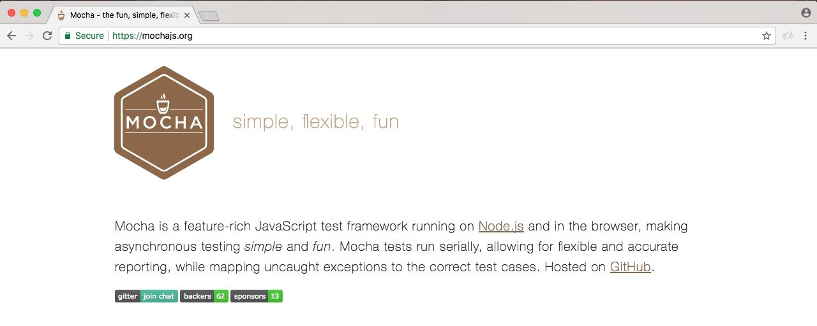

If you scroll down on this page, you'll be able to see a table of contents:

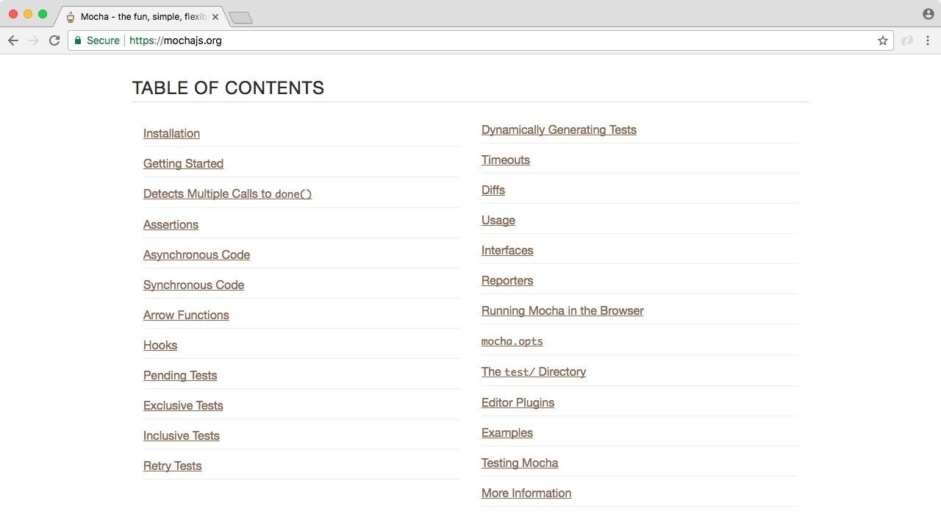

Here you can explore everything Mocha has to offer. We'll be covering most of it in this chapter, but for anything we don't cover, I do want to make you aware you can always learn about it on this page.

Now that we've explored the Mocha documentation page, let's install it and start using it. Inside the Terminal, we'll install Mocha. First up, let's clear the Terminal output. Then we'll install it using the npm install command. When you use npm install, you can also use the shortcut npm i. This has the exact same effect. I'll use npm i with mocha, specifying the version @3.0.0. This is the most recent version of the library as of this filming: **npm i mocha@3.0.0**

Now we do want to save this into the package.json file. Previously, we've used the save flag, but we'll talk about a new flag, called save-dev. The save-dev flag is will save this package for development purposes only—and that's exactly what Mocha will be for. We don't actually need Mocha to run our app on a service like Heroku. We just need Mocha locally on our machine to test our code.

When you use the

save-dev

flag, it installs the module much the same way:

**npm i mocha@5.0.0 --save-dev**

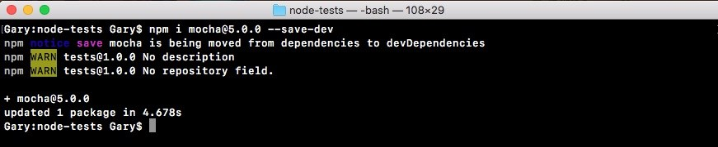

But if you explore

package.json

, you'll see things are a little different. Inside our

package.json file, instead of a dependencies attribute, we have a devDependencies attribute:

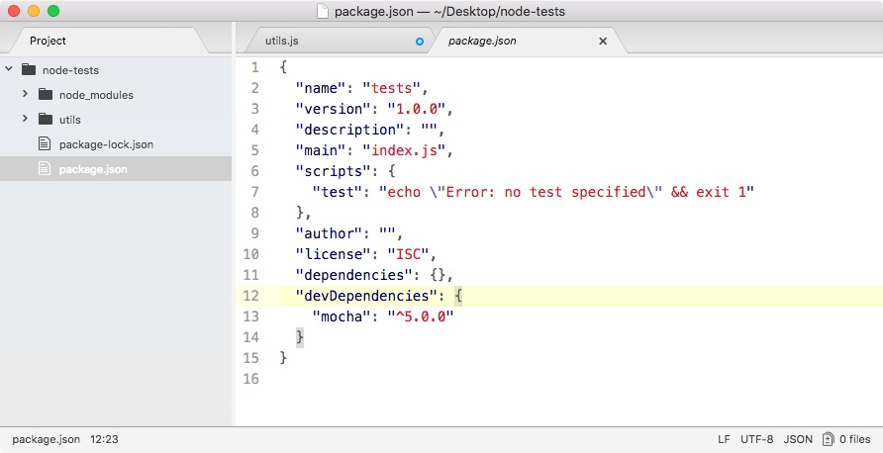

In there we have Mocha, with the version number as the value. The devDependencies are fantastic because they're not going to be installed on Heroku, but they will be installed locally. This will keep the Heroku boot times really, really quick. It won't need to install modules that it's not going to actually need.

We'll be installing both devDependencies and dependencies in most of our projects from here on out.

**Creating a test file for the add function**

Now that we have Mocha installed, we can go ahead and create a test file. In the utils folder, we'll make a new file called utils.test.js:

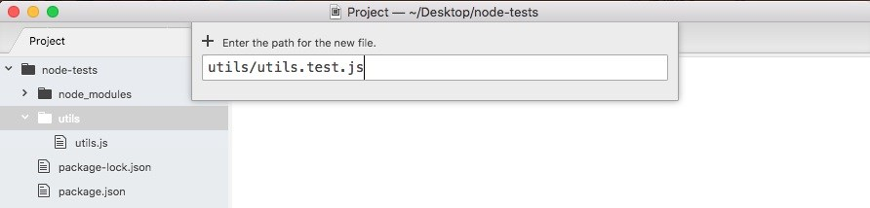

This file will store our test cases. We'll not store our test cases in utils.js. This will be our application code. Instead, we'll make a file called utils.test.js. When we use this test.js extension, we're basically telling our app that this will store our test cases. When Mocha goes through our app looking for tests to run, it should run any file with this extension.

Now we have a test file, the only thing left to do is create a test case. A test case is a function that runs some code, and if things go well, great, the test is considered to have passed. And if things do not go well, the test is considered to have failed. We can create a new test case, using it. It is a function provided by Mocha. We'll be running our project test files through Mocha, so there's no reason to import it or do anything like that. We simply call it just like this: it();

Now it lets us define a new test case and it takes two arguments. These are:

The first argument is a string

The second argument is a function

First up, we'll have a string description of what exactly the test is doing. If we're testing that the adder function works, we might have something like: it('should add two numbers');

Notice here that it plays into the sentence. It should read like this, it should add two numbers; describes exactly what the test will verify. This is called **behaviordriven development**, or **BDD**, and that's the principles that Mocha was built on.

Now that we've set up the test string, the next thing to do is add a function as the second argument:

it('should add two numbers', () => {

});

Inside this function, we'll add the code that tests that the add function works as expected. This means it will probably call add and check that the value that comes back is the appropriate value given the two numbers passed in. That means we do need to import the util.js file up at the top. We'll create a constant, call utils, setting it equal to the return result from requiring utils. We're using ./ since we will be requiring a local file. It's in the same directory so I can simply type utils without the js extension as shown here:

const utils = require('./utils'); it('should add two numbers', () => {

});

Now that we have the utils library loaded in, inside the callback we can call it. Let's make a variable to store the return results. We'll call this one results. And we'll set it equal to utils.add passing in two numbers. Let's use something like 33 and 11:

const utils = require('./utils');

it('should add two numbers', () => { var res = utils.add(33, 11);

});

We would expect it to get 44 back. Now at this point, we do have some code inside of our test suites so we run it. We'll do that by configuring that test script we looked at in the previous chapter inside a package.json.

Currently, the test script simply prints a message to the screen saying that no tests exist. What we'll do instead is call Mocha. As shown in the following code, we'll be calling Mocha, passing in as the one and only argument the actual files we want to test. We can use a globbing pattern to specify multiple files. In this case, we'll be using ** to look in every single directory. We're looking for a file called utils.test.js:

"scripts": {

"test": "mocha **/utils.test.js"

},

Now this is a very specific pattern. It's not going to be particularly useful. Instead, we can swap out the file name with a star as well. Now we're looking for any file on the project that has a file name ending in .test.js:

"scripts": {

"test": "mocha **/*.test.js"

},

And this is exactly what we want. From here, we can run our test suite by saving package.json and moving to the Terminal. We'll use the clear command to clear the Terminal output and then we can run our test script using command shown as follows: **npm test**

When we run this, we'll execute that Mocha command:

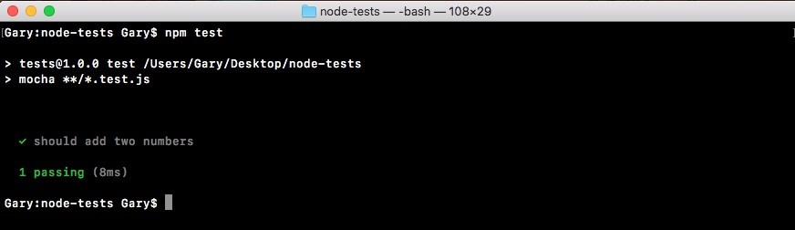

It'll go off. It'll fetch all of our test files. It'll run all of them and print the results on the screen inside Terminal as shown in the preceding screenshot. Here we can see we have a green checkmark next to our test, should add two numbers. Next, we have a little summary, one passing test, and it happened in 8 milliseconds.

Now in our case, we don't actually assert anything about the number that comes back. It could be 700 and we wouldn't care. The test will always pass. To make a test fail what we have to do is throw an error. That means we can throw a new error and we pass into the constructor function whatever message we want to use as the error as shown in the following code block. In this case, I could say something like Value not correct:

const utils = require('./utils');

it('should add two numbers', () => { var res = utils.add(33, 11); throw new Error('Value not correct')

});

Now with this in place, I can save the test file and rerun things from the Terminal by rerunning npm test, and when we do that now we have 0 tests passing and we have 1 test failing:

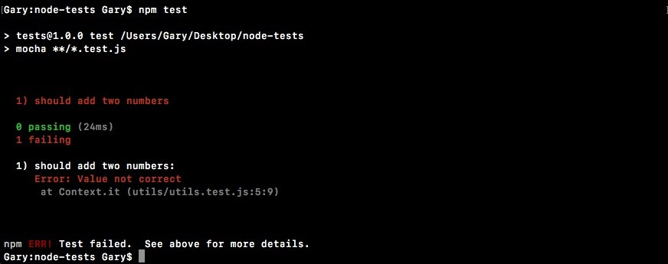

Next we can see the one test is should add two numbers, and we get our error message, Value not correct. When we throw a new error, the test fails and that's exactly what we want to do for add.

**Creating the if condition for the test**

Now, we'll create an if statement for the test. If the response value is not equal to 44, that means we have a problem on our hands and we'll throw an error:

const utils = require('./utils');

it('should add two numbers', () => { var res = utils.add(33, 11);

if (res != 44){

}

});

Inside the if condition, we can throw a new error and we'll use a template string as our message string because I do want to use the value that comes back in the error message. I'll say Expected 44, but got, then I'll inject the actual value, whatever happens to come back:

const utils = require('./utils');

it('should add two numbers', () => { var res = utils.add(33, 11);

if (res != 44){ **throw new Error(`Expected 44, but got ${res}.`);**

}

});

Now in our case, everything will line up great. But what if the add method wasn't working correctly? Let's simulate this by simply tacking on another addition, adding on something like 22 in utils.js: module.exports.add = (a, b) => a + b + 22;

I'll save the file, rerun the test suite:

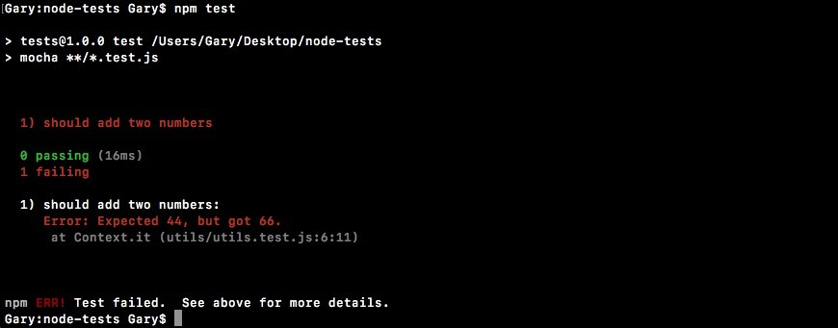

Now we get an error message: Expected 44, but got 66. This error message is fantastic. It lets us know that something is going wrong with the test and it even tells us exactly what we got back and what we expected. This will let us go into the add function, look for errors, and hopefully fix them.

Creating test cases doesn't need to be something super complex. In this case, we have a simple test case that tests a simple function.

**Testing the squaring a number function**

Now, we'll create a new function that squares a number and returns the result.

We'll define that in the utils.js file using module.exports.square. We'll set that equal to an arrow function (=>) that takes in one number, x, and we'll return x times x, x * x, just like this:

module.exports.add = (a, b) => a + b; module.exports.square = (x) => x * x;

Now we have this brand new function square and we'll create a new test case that makes sure square works as expected. In utils.test.js, next to the if condition for add function, we'll call the it function again:

const utils = require('./utils');

it('should add two numbers', () => { var res = utils.add(33, 11);

if (res != 44){ throw new Error(`Expected 44, but got ${res}.`);

} }); **it();**

Inside the it function, we'll add our two arguments, the string, and the callback function. Inside the string, we'll create our message, should square a number:

it('should square a number', () => {

});

And inside the callback function, we can actually go ahead and call square. Now we do want to create a variable to store the result so we can check that the result is what we expect it to be. Then we can call utils.square passing in a number. I'll go with 3 in this case, which means I should expect 9 to come back:

it('should square a number', () => { var res = utils.square(3);

});

In the next line, we can have an if statement, if the result does not equal 9, then we'll throw a message because things went wrong:

it('should square a number', () => { var res = utils.square(3); if (res !== 9) {

}

});

We can throw an error using throw new Error, passing in whatever message we like. We can use a regular string, but I always prefer using a template string so we can inject values easily. I'll say something like Expected 9, but got, followed by the value that's not correct; in this case, that's stored in the response variable:

it('should square a number', () => { var res = utils.square(3);

if (res !== 9) { throw new Error(`Expected 9, but got ${res}`);

}

});

Now I can save this test case and run the test suite from the Terminal. Using the

up arrow key and the

*enter*

key, we can rerun the last command:

**npm test**

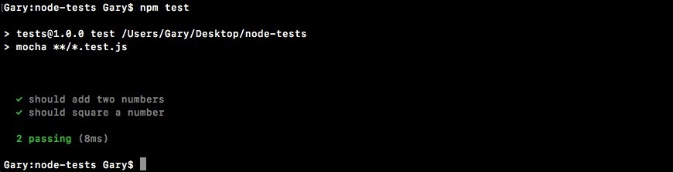

We get two tests passing,

should add two numbers

and

should square a number

both have checkmarks next to them. And we ran both tests in just 14 milliseconds, which is fantastic.

Now the next thing, we want to do is mess up the square function to make sure our test fails when the number is not correct. I'll add 1 on to the result in utils.js, which will cause the test to fail:

module.exports.add = (a, b) => a + b; module.exports.square = (x) => x * x + 1;

Then we can rerun things from the Terminal and we should see the error message:

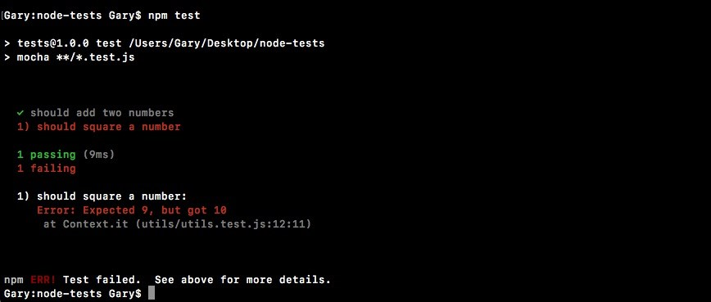

We get Expected 9, but got 10. This is fantastic. We now have a test suite capable of testing both the add function and the square function. I'll remove that + 1, and we are done.

We now have a very, very basic test suite that we can execute with Mocha. Currently, we have two tests and to create those tests we used the it method provided by Mocha. In the upcoming sections, we'll be exploring more methods that Mocha gives us and we'll also be looking at better ways to do our assertions. Instead of manually creating them, we'll be using an assertion library to help with the heavy lifting.

**Autorestarting the tests**

Before we write more test cases, let's see an automatic way to rerun our test suite when we change either our test code or our application code. We'll be doing that with nodemon. Now, previously we used nodemon like this: **nodemon app.js**

We would type nodemon and we would pass in a file like app.js. Whenever any code in our app changed, it would rerun the app.js file as a Node application. What we can actually do is specify any command in the world we want to run when our files change. This means we can rerun npm test when the files change.

To do this, we'll use the exec flag. This flag tells nodemon that we'll specify a command to run, and it might not necessarily be a Node file. As shown in the following command, we can specify that command. It'll be 'npm test': **nodemon --exec 'npm test'**



*If you are using Windows, remember to use double quotes in place of single quotes.*

With this in place, we can now run the nodemon command. It'll kick off for the first time running our test suite:

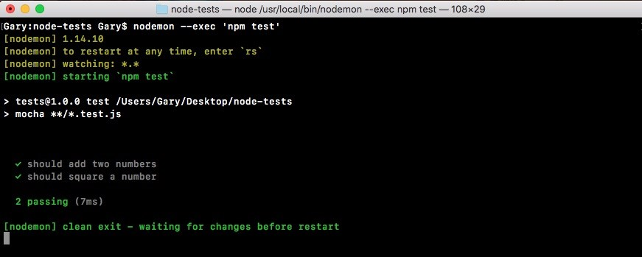

Here we see we have two tests passing. Let's go ahead into the app utils.js and make a change to one of the functions, so it fails. We'll add 3 or 4 onto the result for add:

module.exports.add = (a, b) => a + b + 4; module.exports.square = (x) => x * x;

It automatically restarts over here:

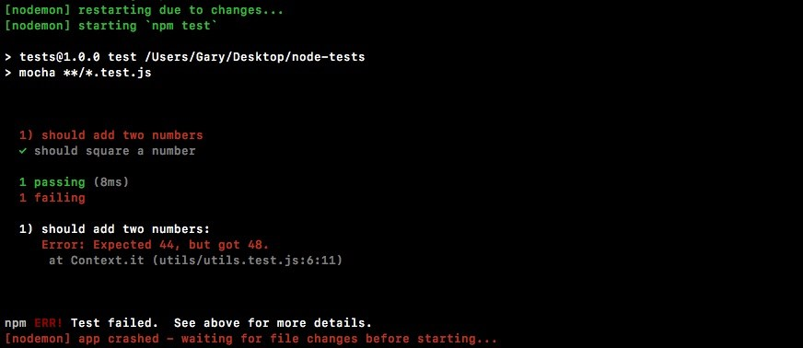

And now we see that we have a test suite where one test passes and one tests fails. I can always go ahead and undo that error we added, save the file, and the test suite will automatically rerun.

This will make testing your application that much easier. You won't have to switch to the Terminal and rerun the npm test command every time we make a change to our application. Now we have a command that we can run, we'll shut down nodemon and use the up arrow key to show it again.

And we can actually move this into a script inside of package.json.

Inside package.json we'll make a new script right after the test script. Now we've used the start script and the test script—these are built-in—we'll create a custom one called test-watch, and we can run the test-watch script to kick things off. Inside of test-watch, we'll have the exact same command we ran from Terminal. That means we'll be rounding nodemon. We'll be using the exec flag and inside of quotes, we'll be running npm test:

"scripts": {

"test": "mocha **/*.test.js",

"test-watch": "nodemon --exec 'npm test'" },

Now that we have this in place, we can run the script from the Terminal as opposed to having to type out this command every single time we want to start up the autotest suite.

*The script we have inside package.json currently will work on macOS and Linux. It'll also work on Heroku, which uses Linux. But it will not work on Windows. The following script will:*

*"test-watch": "nodemon --exec \"npm test\"".*

*As you can see here, we're escaping the quotes surrounding npm test and we're using double quotes, which as we know are the only quotes supported by Windows. This script will remove any errors you're seeing, something like npm cannot be found, which you will get if you wrap npm tests in single quotes and run the script on Windows. So use the above script for cross-OS compatibility.*

To run a script with a custom name, such as test-watch, in the Terminal all we need to do is run npm run followed by the script name, test-watch, as shown in the following command:

**npm run test-watch**

If I do this, it will start things off. We'll get our test suite and it's still waiting for changes, as shown here:

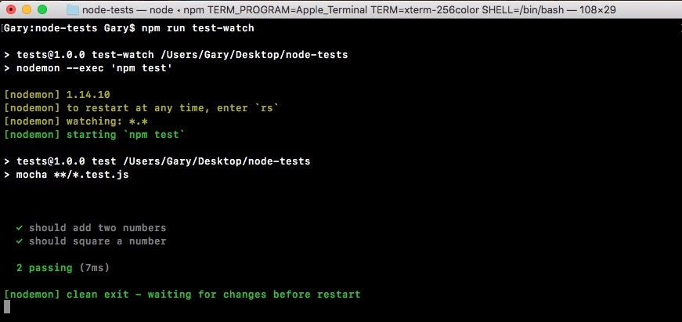

Now, every time you start the test suite you can simply use npm run test-watch. That'll start up the test-watch script, which starts up nodemon. Every time a change happens in your project, it'll rerun npm test, showing the results of the test suite to the screen.

Now that we have a way to automatically restart our test suite, let's go ahead and get back into the specifics of testing in Node.

**Using assertion libraries in testing Node modules**

In the previous sections, we made two test cases to verify that utils.add and our utils.square method work as expected. We did that using an if condition, that is, if the value was not 44 that means something went wrong and we threw an error. In this section, we'll learn how to use an assertion library, which will take care of all of the if condition in utils.test.js code for us:

if (res !== 44) throw new Error(`Expected 44, but got ${res}.`) }

Because when we add more and more tests, the code will end up looking pretty similar and there's no reason to keep rewriting it. Assertion libraries let us make assertions about values, whether it's about their type, the value itself, whether an array contains an element, all sorts of things like that. They really are fantastic.

The one we'll be using is called expect. You can find it by going to Google and googling mjackson expect. And this is the result we're looking for:

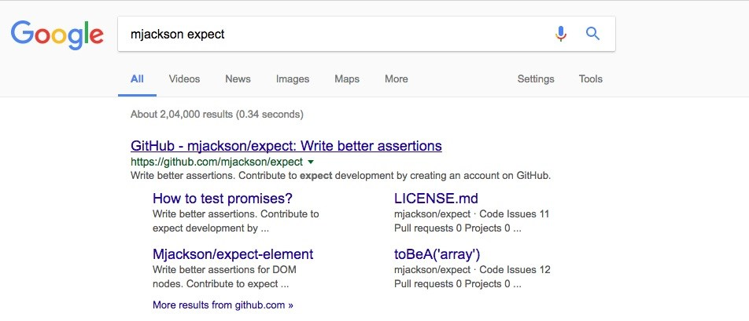

It's mjackson's repository, expect. It is a fantastic and super popular assertion library. This library will let us pass in a value and make some assertions about it. On this page, we scroll down past the introduction and the installation we can get down to an example:

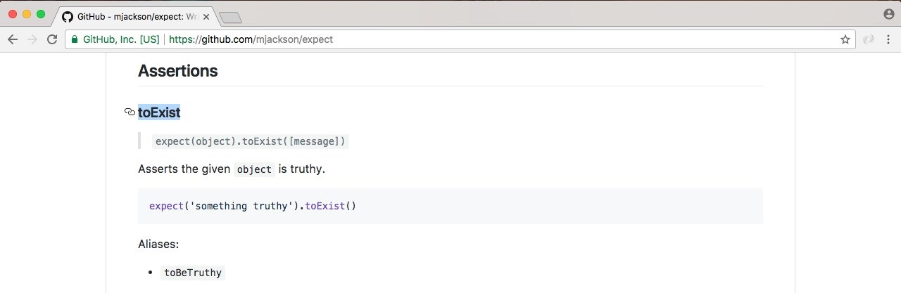

As shown in the preceding screenshot, we have our Assertions header and we have our first assertion, toExist. This will verify that a value exists. In the next line, we have an example, we pass in a string to expect:

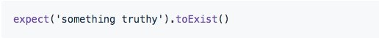

This is the value we want to make some assertions about. In the context of our application, that would be the response variable in the utils.test.js, shown here:

const utils = require('./utils');

it('should add two numbers', () => { var res = utils.add(33, 11); if (res !== 44) { throw new Error(`Expected 44, but got ${res}.`)

}

});

We want to assert that it is equal to 44. After we call expect, we can start chaining on some assertion calls. In the assertion example, next we check if it does exist: expect('something truthy').toExist()

This would not throw an error because a string is indeed truthy inside JavaScript.

If we passed in something like undefined, which is not truthy, toExist would fail. It would throw an error and the test case would not pass. Using these assertions, we can make it really, really easy to check the values in our tests without having to write all of that code ourselves.

**Exploring assertion libraries**

Let's go ahead and start exploring the assertion libraries. First up, let's install the module inside the Terminal by running npm install. The module name itself is called expect and we'll grab the most recent version, @1.20.2. Once again, we'll be using the save-dev flag like we did with Mocha. Because we do indeed want to save this dependency in package.json, but it's a dev dependency, it's not required for the application to run whether it's on Heroku or some other service: **npm install expect@1.20.2 --save-dev**

*The expect library has been donated to a different organization. The latest version, which is v21.1.0 is not compatible with the backward version we are using here that is 1.20.2. What I like you to do is install the 1.20.2 version in the section that will make sure, you'll use in next several sections.*

Let's go ahead and install this dependency.

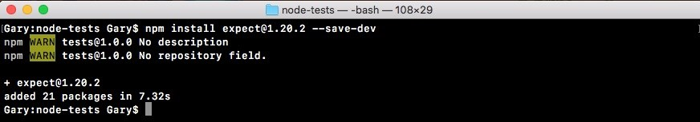

Then we can move to the application, and check out the package.json file, as shown in the following screenshot, it looks great:

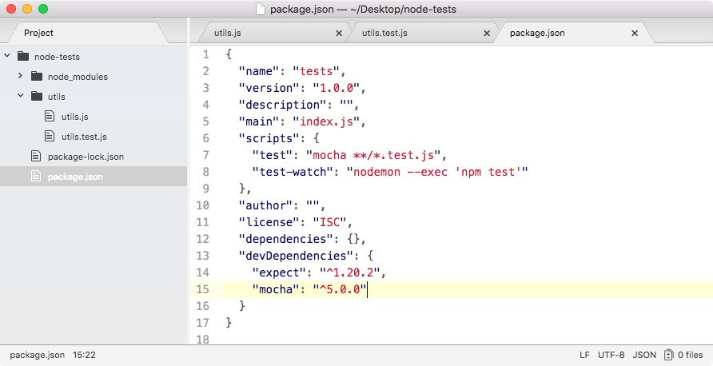

We have both expect and Mocha. Now, inside our utils.test file, we can kick things off by loading in the library and making our first assertions using expect. Up at the very top of the file, we'll load in the library, creating a constant called expect and require('expect'), just like this: const expect = require('expect');

Now, we can get started by swapping out the if condition in the utils.test.js code with a call to expect instead:

const expect = require('expect'); const utils = require('./utils');

it('should add two numbers', () => { var res = utils.add(33, 11);

// if(res !== 44) {

// throw new Error(`Expected 44, but got ${res}.`)

//}

});

As you saw in the example on assertion/expect page, we'll start all our assertions by calling expect as a function passing in the value we want to make assertions about. In this case, that is the res variable:

const expect = require('expect'); const utils = require('./utils');

it('should add two numbers', () => { var res = utils.add(33, 11);

**expect(res)**

// if(res !== 44) {

// throw new Error(`Expected 44, but got ${res}.`)

//}

});

Now, we can assert all sorts of things. In this case, we want to assert that the value is equal to 44. We'll make our assertion toBe. On the documentation page, it looks like this:

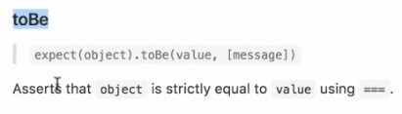

This asserts that a value equals another value and that's exactly what we want. We assert that our value passed into expect equals another value using toBe, passing that value in as the first argument. Back inside Atom, we can go ahead and use this assertion, .toBe, and we're expecting the result variable to be the number 44, just like this:

const expect = require('expect'); const utils = require('./utils');

it('should add two numbers', () => { var res = utils.add(33, 11);

**expect(res).toBe(44);**

// if(res !== 44) {

// throw new Error(`Expected 44, but got ${res}.`)

//}

});

Now we have our test case and it should work exactly as it did with the if condition.

To prove it does work, let's move into the Terminal and use the clear command to clear the Terminal output. Now we can run that test-watch script as shown in the following command line:

**npm run test-watch**

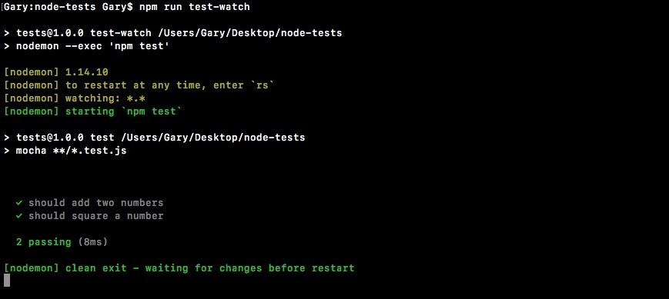

As shown in the preceding code output, we get our two tests passing just like

they did before. Now we were to change 44 to some other value that would throw an error like 40:

const expect = require('expect'); const utils = require('./utils');

it('should add two numbers', () => { var res = utils.add(33, 11);

**expect(res).toBe(40);**

// if(res !== 44) {

// throw new Error(`Expected 44, but got ${res}.`) //}

});

We save the file, and we'll get an error and the expect library will generate useful error messages for us:

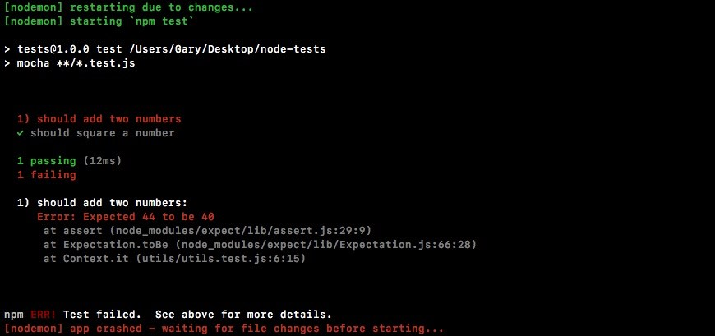

It's saying that we Expected 44 to be 40. Clearly that's not the case, so an error gets thrown. I'll change this back to 44, save the file, and all of our tests will pass.

**Chaining multiple assertions**

Now we can also chain together multiple assertions. For example, we could assert that the value that comes back from add is a number. This can be done using another assertion. So let's head into the docs and take a look. Inside Chrome, we'll scroll down through the assertion docs list. There are a lot of methods. We'll be exploring some of them. In this case, we're looking for toBeA, the method that takes a string:

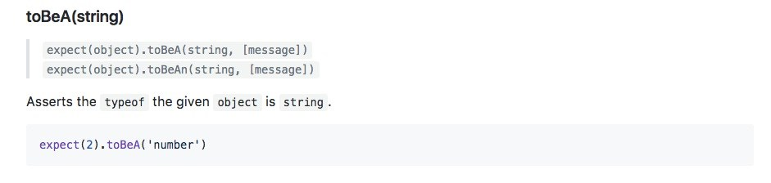

This takes the string type and it uses the typeof operator to assert that the value is of a certain type. Here we're expecting 2 to be a number. We can do that exact same thing over in our code. Inside Atom, right after toBe, we can chain on another call, toBeA, followed by the type. This could be something like a string, it could be something like an object, or in our case, it could be a number, just like this:

const expect = require('expect'); const utils = require('./utils');

it('should add two numbers', () => { var res = utils.add(33, 11);

**expect(res).toBe(44).toBeA('number');**

// if(res !== 44) {

// throw new Error(`Expected 44, but got ${res}.`)

//}

});

We'll open up the Terminal so we can see the results. It's currently hidden. Save the file. Our tests will rerun and we can see they're both passing:

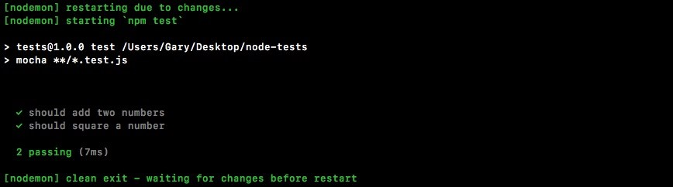

Let's use a different type, something that was going to cause the test to fail for example string: expect(res).toBe(44).toBeA('string');

We would then get an error message, Expected 44 to be a string:

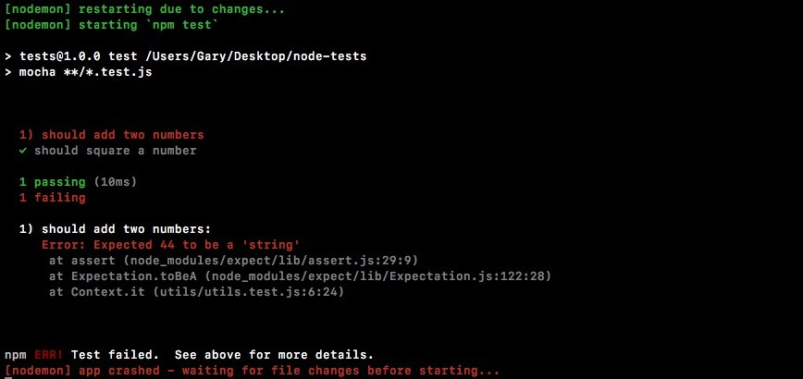

This is really useful. It'll help us clean up our errors really quickly. Let's change the code back to number and we are good to go.

**Multiple assertions for the square function**

Now we'd like to do the same thing for our tests for square a number function. We'll use expect to assert that the response is indeed the number 9 and that the type is a number. We'll use these same two assertions we do with the add function. First, we need to do to delete the current square if condition code, since we will not be using that anymore. As shown in the following code, we'll make some expectations about the res variable. We'll expect it to be the number 9, just like this:

it('should square a number', () => { var res = utils.square(3);

**expect(res).toBe(9);**

});

We'll save the file and make sure the test passes, and it does indeed pass:

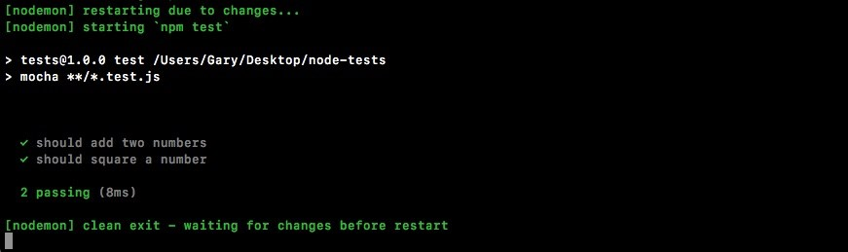

Now, we'll assert the type using toBeA. Here, we're checking that the type of the return value from the square method is a number:

it('should square a number', () => { var res = utils.square(3);

**expect(res).toBe(9).toBeA('number');** });

When we save the file, we get both of our tests still passing, which is fantastic:

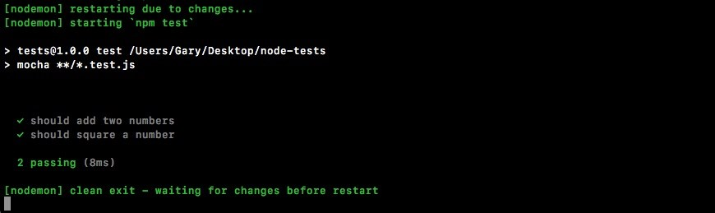

Now this is just a small test as to what expect can do. Let's create a bogus test case that will explore a few more ways we can use expect. We'll not be testing an actual function. We'll just play around with some assertions inside of the it callback.

**Exploring usage of expect with bogus test**

To create the bogus test, we'll make a new test using the it callback function: it('should expect some values');

We can put whatever we want in here, it's not too important. And we'll pass in an arrow function (=>) as our callback function:

it('should expect some values', () => {

});

Now as we've seen already, one of the most fundamental assertions you'll make is you're just going to check for equality. We want to check if something like the response variable equals something else, like the number 44. Inside expect, we can also do the opposite. We can expect that a value like 12 does not equal, using toNotBe. And then we can assert that it doesn't equal some other value, like 11:

it('should expect some values', () => { expect(12).toNotBe(11);

});

The two aren't equal, so when we save the file over in the Terminal, all three tests should be passing:

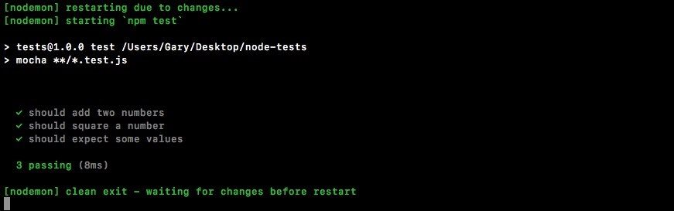

If I set that equal to the same value, it'll not work as expected:

it('should expect some values', () => { expect(12).toNotBe(12);

});

We'll get an error, Expected 12 to not be 12:

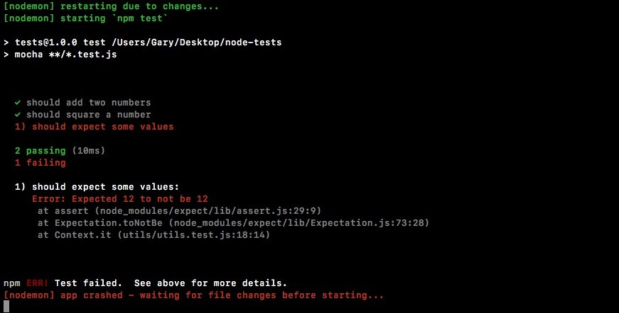

Now toBe and toNotBe work great for numbers, strings, and Booleans, but if you're trying to compare arrays or objects, they will not work as expected and we can prove this.

**Using toBe and toNotBe to compare array/objects**

We'll start with removing the current code by commenting it out. We'll leave it around so we use it later:

it('should expect some values', () => {

// expect(12).toNotBe(12);

});

We'll expect an object with the name property set to Andrew, toBe, and we'll assert that it is another object where the name property is equal to Andrew, just like this:

it('should expect some values', () => {

// expect(12).toNotBe(12); expect({name: 'Andrew'})

});

We'll use toBe, just like we did with number, checking if it is the same as another object where name equals Andrew:

it('should expect some values', () => {

// expect(12).toNotBe(12);

expect({name: 'Andrew'}).toBe({name: 'Andrew'}); });

Now when we save this, you might think the test will pass, but it doesn't:

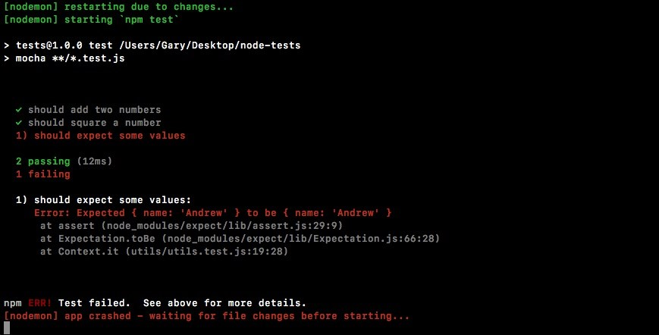

As shown in the preceding output, we see that we expected the two names to be equal. When objects are compared for equality using the triple equals, which is what toBe uses, they'll not be the same because it's trying to see if they're the exact same object, and they're not. We've created two separate objects with the same properties.

**Using the toEqual and toNotEqual assertions**

To check if the two names are equal, we'll have to use something different. It's called toEqual as shown here:

it('should expect some values', () => {

// expect(12).toNotBe(12);

expect({name: 'Andrew'}).toEqual({name: 'Andrew'}); });

If we save the file now, this will work. It'll rip into the object properties, making sure they have the same ones:

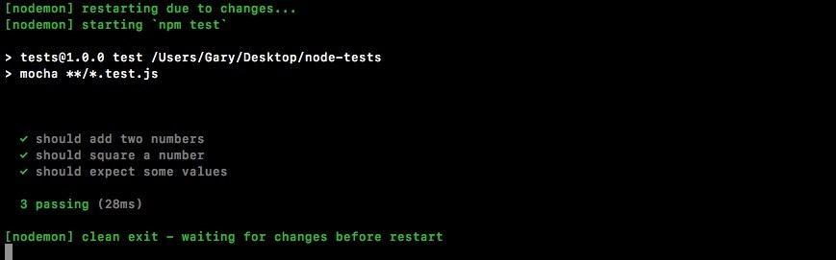

The same thing goes for toNotEqual. This checks if two objects are not equal. To check this, we'll go ahead and change the first object to have a lowercase a in

andrew:

it('should expect some values', () => {

// expect(12).toNotBe(12);

expect({name: 'andrew'}).toNotEqual({name: 'Andrew'}); });

Now, the test passes. They are not equal:

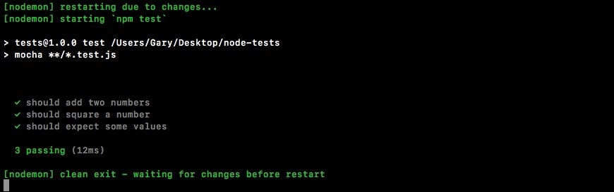

This is how we do equality with our objects and arrays. Now another really useful thing we have is toInclude.

**Using toInclude and toExclude**

The toInclude assertion checks if an array or an object includes some things. Now if it's an array, we can check if it includes a certain item in the array. If it's an object, we can check if it includes certain properties. Let's run through an example of that.

We'll expect that an array with the numbers 2, 3, and 4 inside the it callback has the number 5 inside and we can do that using toInclude:

it('should expect some values', () => {

// expect(12).toNotBe(12);

// expect({name: 'andrew'}).toNotEqual({name: 'Andrew'}); expect([2,3,4]).toInclude(5);

});

The toInclude assertion takes the item. In this case, we'll check if the array has 5 inside. Now clearly it doesn't, so this test will fail:

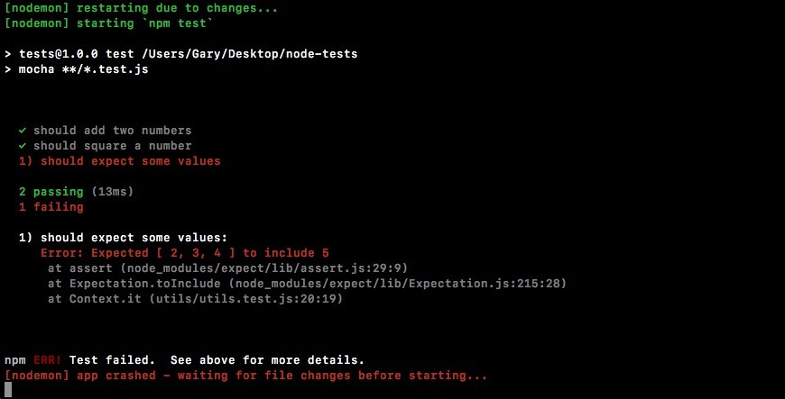

We get the message, Expected [ 2, 3, 4] to include 5. That does not exist. Now we change this to a number that does exist, for example 2:

it('should expect some values', () => {

// expect(12).toNotBe(12);

// expect({name: 'andrew'}).toNotEqual({name: 'Andrew'}); expect([2,3,4]).toInclude(2);

});

We'll rerun the test suite and everything will work as expected:

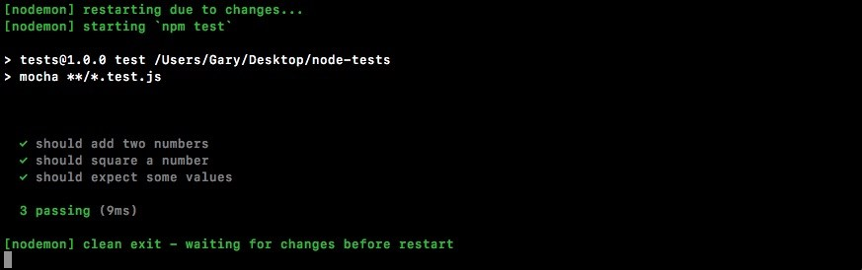

Now, along with toInclude, we have toExclude like this:

it('should expect some values', () => {

// expect(12).toNotBe(12);

// expect({name: 'andrew'}).toNotEqual({name: 'Andrew'}); **expect([2,3,4]).toExclude(1);**

});

This will check if something does not exist, for example the number 1, which is not in the array. If we run this assertion, the test passes:

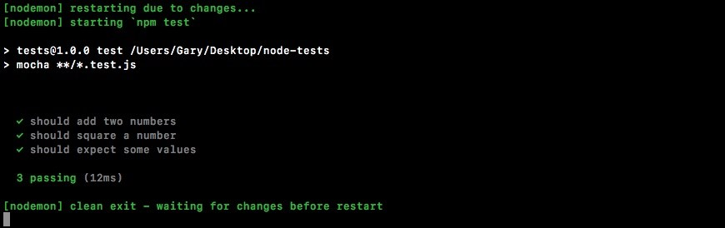

The same two methods, toInclude and toExclude, work with objects as well. We can play with that right on the next line. I'll expect that the following object has something on it:

it('should expect some values', () => {

// expect(12).toNotBe(12);

// expect({name: 'andrew'}).toNotEqual({name: 'Andrew'});

// expect([2,3,4]).toExclude(1); expect({

})

});

Let's go ahead and create an object that has a few properties. These are:

name: We'll set it equal to any name, let's say Andrew.

age: We'll set that equal to age, say 25.

location: We'll set that equal to any location, for example Philadelphia.

This will look like the following code block:

it('should expect some values', () => {

// expect(12).toNotBe(12);

// expect({name: 'andrew'}).toNotEqual({name: 'Andrew'});

// expect([2,3,4]).toExclude(1); expect({ **name: 'Andrew', age: 25,**

**location: 'Philadelphia'**

})

});

Now let's say we want to make some assertions about particular properties, not necessarily the entire object. We can use toInclude to assert that the object has some properties and that those property values equals the value we pass in:

it('should expect some values', () => {

// expect(12).toNotBe(12);

// expect({name: 'andrew'}).toNotEqual({name: 'Andrew'});

// expect([2,3,4]).toExclude(1); expect({ name: 'Andrew', age: 25, location: 'Philadelphia' }).**toInclude({**

**})**

});

For example, the age property. Let's say we only care about the age. We can assert that the object has an age property equal to 25 by typing the following code:

it('should expect some values', () => {

// expect(12).toNotBe(12);

// expect({name: 'andrew'}).toNotEqual({name: 'Andrew'});

// expect([2,3,4]).toExclude(1); expect({ name: 'Andrew', age: 25, location: 'Philadelphia'

}).toInclude({ **age: 25**

})

});

It doesn't matter that there's a name property. The name property could be any value. That is irrelevant in this assertion. Now let's use the value, 23:

.toInclude({ **age: 23**

})

This test will fail as shown here since the value is not correct:

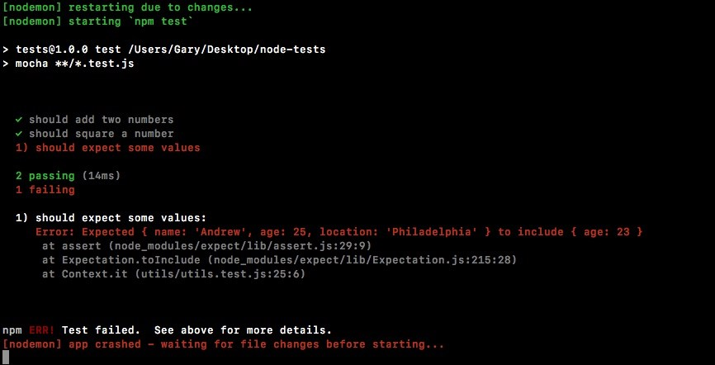

We expected the age property to be 23, but it was indeed 25, so the test fails. The same thing goes with the toExclude assertion.

Here we can save our test files. This checks if the object does not have a property age equal to 23. It does indeed not have that, so the test passes:

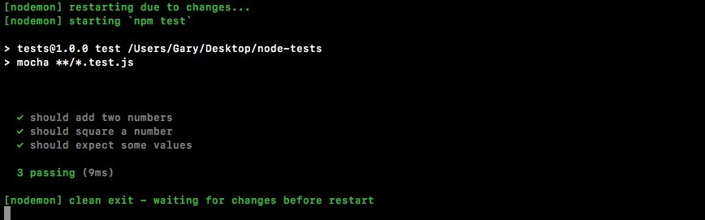

This is just a quick taste as to what expect can do. For a full list of features, I recommend diving through the documentation. There's a ton of other assertions you can use, things like checking if a number is greater than another number, if a number is less than or equal to another number, all sorts of math-related operations are included as well.

**Testing the setName method**

Now let's wrap up this section with some more testing. Over in utils.js, we can make a new function, one that we'll be testing, module.exports.setName. The setName function is will take two arguments. It'll take a user object, some fictitious user object with some generic properties, and it'll take fullName as a string:

module.exports.add = (a, b) => a + b; module.exports.square = (x) => x * x; module.exports.setName (user, fullName)

The job of setName will be to rip apart fullName into two parts—the first name and the last name—by splitting it on the space. We'll set the two properties, first name and last name, and return the user object. We'll fill out the function then we'll write the test case.

The first thing we'll do is split the name into a names array, var names will be that array:

module.exports.add = (a, b) => a + b; module.exports.square = (x) => x * x;

module.exports.setName (user, fullName) => { var names };

It'll have two values, assuming there's only one space inside of the name. We're assuming someone types their first name, hits a space, and types their last name.

We'll set this equal to fullName.split and we'll split on the space. So I'll pass in an empty string with a space inside it as the value to split:

module.exports.add = (a, b) => a + b; module.exports.square = (x) => x * x;

module.exports.setName (user, fullName) => { var names = fullName.split(' ');

};

Now we have a names array where the first item is the firstName and the last item is the lastName. So we can start updating the user object. user.firstName will equal the first item in the names array and we'll grab the index of 0, which is the first item. We'll do something similar for last name, user.lastName equals the second item from the names array:

module.exports.add = (a, b) => a + b; module.exports.square = (x) => x * x;

module.exports.setName (user, fullName) => { var names = fullName.split(' '); user.firstName = names[0]; user.lastName = names[1];

};

Now we're all done, we have the names set, and we can return the user object using return user, just like this:

module.exports.add = (a, b) => a + b; module.exports.square = (x) => x * x;

module.exports.setName (user, fullName) => { var names = fullName.split(' '); user.firstName = names[0]; user.lastName = names[1]; **return user;** };

Inside the utils.test file, we can now kick things off. First, we'll comment out our it('should expect some values') handler:

const expect = require('expect'); const utils = require('./utils');

it('should add two numbers', () => { var res = utils.add(33, 11);

expect(res).toBe(44).toBeA('number');

});

it('should square a number', () => { var res = utils.square(3);

expect(res).toBe(9).toBeA('number'); });

**// it('should expect some values', () => {**

**// // expect(12).toNotBe(12);**

**// // expect({name: 'andrew'}).toNotEqual({name: 'Andrew'});**

**// // expect([2,3,4]).toExclude(1);**

**// expect({**

**// name: 'Andrew',**

**// age: 25,**

**// location: 'Philadelphia'**

**// }).toExclude({**

**// age: 23**

**// })**

**// });**

This is pretty great for documentation. You can always explore it later if you forget how things work. We'll create a new test that should verify first and last names are set.

We'll create a user object. On that user object, we want to set some properties such as age and location. Then we'll pass the variable user into the setName method. That'll be the first argument defined in the utils.js file. We'll pass in a string. The string with firstName followed by a space followed by lastName. Then we'll get the result back and we'll make some assertions about it. We want to assert the returning object includes using the toInclude assertion.

As shown in the following code, we'll call it to make the new test case. We'll be testing: it('should set firstName and lastName')

Inside it, we can now provide our second argument, which will be our callback function. Let's set that to an arrow function (=>) and now we can make the user object:

it('should set firstName and lastName', () => {

});

The user object will have a few properties. Let's add something like location, setting that equal to Philadelphia, and then set an age property, setting that equal to 25:

it('should set firstName and lastName', () => { var user = {location: 'Philadelphia', age: 25}; });

Now we'll call the method we defined over in utils.js, the setName method. We'll do that on the next line, creating a variable called res to store the response. Then we'll set that equal to utils.setName passing in the two arguments, the user object and fullName, Andrew Mead:

it('should set firstName and lastName', () => { var user = {location: 'Philadelphia', age: 25}; var res = utils.setName(user, 'Andrew Mead'); });

Now at this point, the result should be what we expect. We should have the firstName and lastName properties. We should have the location property and the age property.

Now if you know a lot about JavaScript, you might know that objects are passed by reference, so the user variable has actually been updated as well. That is expected. Both user and res will have the exact same value. We can actually go ahead and prove that using an assertion. We'll expect that user equals using toEqual the res:

it('should set firstName and lastName', () => { var user = {location: 'Philadelphia', age: 25}; var res = utils.setName(user, 'Andrew Mead');

expect(user).toEqual(res);

});

Inside Terminal, we can see the test does indeed pass:

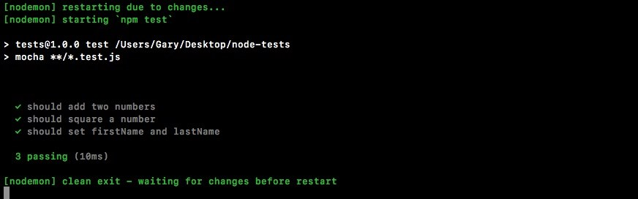

Let's delete expect(user).toEqual(res);. Now, we want check if the user object or the res object includes certain properties. We'll check using expect that the res variable has some properties using toInclude:

it('should set firstName and lastName', () => { var user = {location: 'Philadelphia', age: 25}; var res = utils.setName(user, 'Andrew Mead');  **expect(res).toInclude({**

**})**

});

The properties we're looking for are firstName equal to what we would expect that to be, Andrew, and lastName equal to Mead:

it('should set firstName and lastName', () => { var user = {location: 'Philadelphia', age: 25}; var res = utils.setName(user, 'Andrew Mead');

expect(res).toInclude({ **firstName: 'Andrew', lastName: 'Mead'**

})

});

These are the assertions that should be made in order to verify that setName is working as expected. If I save the file, the test suite reruns and we do indeed get the passing tests as shown here:

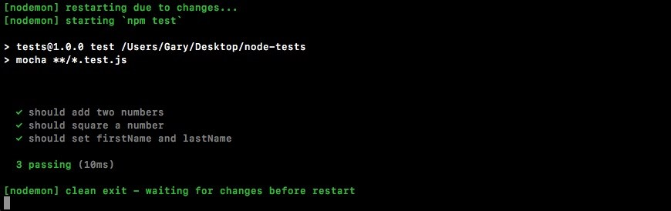

We have three of them and it took just 10 milliseconds to run.

And with this in place, we now have an assertion library for our test suite. That's fantastic because writing test cases just got way easier, and the whole goal of the chapter is to make testing approachable and easy.

In the next section, we'll start looking at how we can test more complex asynchronous functions.

**The asynchronous testing**

In this section, you'll learn how to test asynchronous functions. The process of testing asynchronous functions isn't that different from synchronous ones, like what we've done already, but it is a little different so it justifies its own section.

**Creating the asyncAdd function using the setTimeout object**

To kick things off, we'll make a fake async function using setTimeout to simulate a delay inside utils.js. Just below where we make our add function, let's make one called asyncAdd. It'll essentially have the same features, but it'll use setTimeout and it'll have a callback to simulate a delay. Now in the real world, this delay might be a database request or an HTTP request. We'll be dealing with that in the following chapters. For now though, let's add module.exports.asyncAdd:

module.exports.add = (a, b) => a + b; module.exports.asyncAdd = ()

This will take three arguments, as opposed to the two the add function took, a, b, and callback:

module.exports.add = (a, b) => a + b; module.exports.asyncAdd = (a, b, callback)

This is what's going to make the function asynchronous. Eventually, once the setTimeout is up, we'll call the callback with the sum, whether it's one plus three being four, or five plus nine being fourteen. Next up, we can put the arrow in arrow function (=>) and open and close our curly braces:

module.exports.asyncAdd = (a, b, callback) => {

};

Inside the arrow function (=>), as mentioned, we'll be using setTimeout to create the delay. We'll pass in a callback and we'll pass in our setTimeout. Let's go with 1 second in this case:

module.exports.asyncAdd = (a, b, callback) => { setTimeout(() => {

}, 1000);

};

Now, by default, if our tests take longer than 2 seconds, Mocha will assume that is not what we wanted and it'll fail. That's why we're using 1 second in this case.

Inside our callback, we can call the actual callback argument with the sum a + b, just like this:

module.exports.asyncAdd = (a, b, callback) => { setTimeout(() => { callback(a + b);

}, 1000);

};

We now have an asyncAdd function and we can start writing a test for it.

**Writing the test for the asyncAdd function**

Inside of the utils.test file, just under our previous test for utils.add, we'll add a new one for asyncAdd. The test setup will look really similar. We will be calling it and passing in a string as the first argument and a callback as the second argument. Then we'll add our callback, just like this:

it('should async add two numbers', () => {

});

Inside the callback, we can get started calling utils.asyncAdd. We'll call it using utils.asyncAdd and we'll pass in those three arguments. We'll use 4 and 3, which should result in 7. And we'll provide the callback function, which should get called with that value, the value being 7:

it('should async add two numbers', () => { utils.asyncAdd(4, 3, () => {

});

});

Inside the callback arguments, we would expect something like sum to come back:

it('should async add two numbers', () => { utils.asyncAdd(4, 3, (sum) => {

});

});

**Making assertion for the asyncAdd function**

Now we can start making some assertions about that sum variable using the expect object. We can pass it into expect to make our assertions, and these assertions aren't going to be new. It's stuff we've already done. We'll expect that the sum variable equals, using toBe, the number 7. Then we'll check that it's a number, using toBeA, inside quotes, number:

it('should async add two numbers', () => { utils.asyncAdd(4, 3, (sum) => { expect(sum).toBe(7).toBeA('number');

});

});

Now obviously if it is equal to 7 that means it is a number, but we're using both just to simulate exactly how chaining will work inside of our expect calls.

Now that we have our assertions in place, let's save the file and run our test and see what happens. We'll run it from Terminal, npm run test-watch to start up our nodemon watching script: **npm run test-watch**

Now our tests will run and the test does indeed pass:

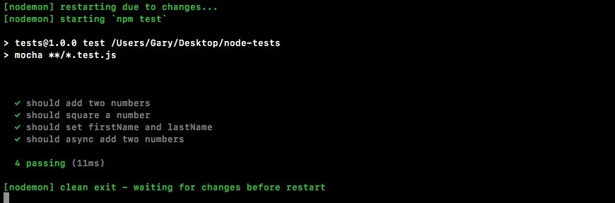

The only problem is that it's passing for the wrong reasons. If we change 7 to 10 and save the file:

it('should async add two numbers', () => { utils.asyncAdd(4, 3, (sum) => { expect(sum).toBe(10).toBeA('number');

});

});

In this case, the test is still going to pass. Right here, you see we have four tests passing:

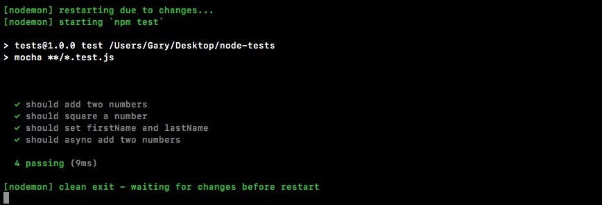

**Adding the done argument**

Now the reason this test is passing is not because the assertion in utils.test.js is valid. It's passing because we have an asynchronous action that takes 1 second. This function will return before the async callback gets fired. When I say function returning, I'm referring to the callback function, the second argument to it.

This is when Mocha thinks your test is done. This means that these assertions never run. The Mocha output has already said our test passes before this callback ever gets fired. What we need to do is tell Mocha this will be an asynchronous test that'll take time. To do this, all we do is we provide an argument inside the callback function we pass to it. We'll call this one done: it('should async add two numbers', (done) => {

When we have the done argument specified, Mocha knows that means we have an asynchronous test and it'll not finish processing this test until done gets called. This means we can call done after our assertions:

it('should async add two numbers', (done) => { utils.asyncAdd(4, 3, (sum) => { expect(sum).toBe(10).toBeA('number'); **done();**

});

});

With this in place, our test will now run. The function will return right after it calls async.Add, but that's OK because we have done specified. About a second later, our callback function will fire. Inside the asyncAdd callback function, we'll make our assertions. This time the assertions will matter because we have done and we haven't called it yet. After the assertions we call done, this tells Mocha that we're all done with the test. It can go ahead and process the result, letting us know whether it passed or failed. This will fix that error.

If I save the file in this state, it'll rerun the tests and we'll see that our test should async.Add two numbers will indeed fail. Inside Terminal, let's open up the error message, we have Expected 7 to be 10:

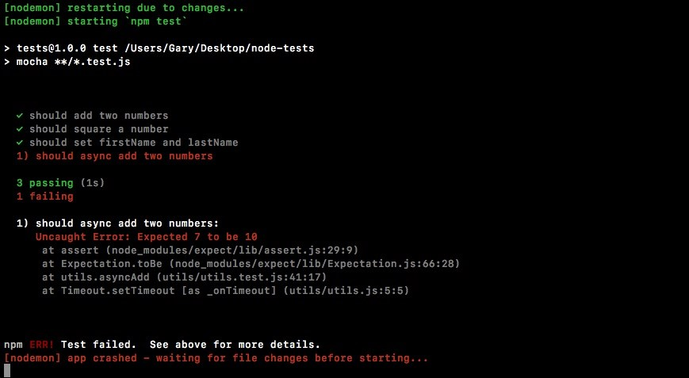

This is exactly what we thought would happen the first time around when we didn't use done, but as we can see, we do need to use done when we're doing something asynchronous inside of our tests.

Now we can change this expectation back to 7, save the file:

it('should async add two numbers', (done) => { utils.asyncAdd(4, 3, (sum) => { expect(sum).toBe(7).toBeA('number'); done();

});

});

This time around things should work as expected after 1 second delay as it runs this test:

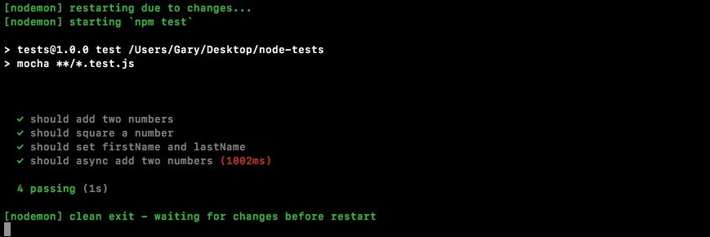

It can't report right away because it has to wait for done to get called. Notice that our total test time is now about a second. We can see that we have four tests passing. Mocha also warns us when a test takes a long time because it assumes that's not expected. Nothing inside Node, even a database or HTTP request, should take even close to a second, so it's essentially letting us know that there's probably an error somewhere inside of your function—it's taking a really, really long time to process. In our case though, the one second delay was clearly set up inside of utils so there's no need to worry about that warning.

With this in place, we now have a test for our very first asynchronous method. All we had to do is add a done as an argument and call it once we were done making our assertions.

**The asynchronous testing for the square function**

Now let's create an asynchronous version of the square method as we did with the synchronous one. In order to get started, we'll define the function first and then we'll worry about writing that test.

**Creating the async square**

**function**

Inside the utils file, we can get started next to the square method creating a new one called asyncSquare:

module.exports.square = (x) => x * x; module.exports.asyncSquare

It'll take two arguments: the original argument which we called x, and the callback function that'll get called after our 1-second delay:

module.exports.square = (x) => x * x; module.exports.asyncSquare = (x, callback) => {

};

Then we can finish up the arrow function (=>) and we can start working on the body of asyncSquare. It'll look pretty similar to the asyncAdd one. We'll call setTimeout passing in a callback and a delay. In this case, the delay will be the same; we'll go with 1 second:

module.exports.square = (x) => x * x;

module.exports.asyncSquare = (x, callback) => { setTimeout(() => {

}, 1000);

};

Now we can actually call the callback. This will trigger the callback function that got passed in and we'll pass in the value x times x, which will properly square the number passed in place of x:

module.exports.square = (x) => x * x;

module.exports.asyncSquare = (x, callback) => { setTimeout(() => { callback(x * x);

}, 1000);

};

**Writing test for asyncSquare**

Now inside the test file, things are indeed passing, but we haven't added a test for the asyncSquare function so let's do that. Inside the utils.test file, the next thing you needed to do was call it. Next to it for testing the asyncAdd function, let's call it to make a new test for this asyncSquare function:

it('should square a number', () => { var res = utils.square(3);

expect(res).toBe(9).toBeA('number');

}); **it('should async square a number')**

Next up, we'll provide the callback function that'll get called when the test actually executes. And since we are testing an async function, we'll put done in the callback function as shown here:

it('should async square a number', (done) => {

});

This will tell Mocha to wait until done is called to decide whether or not the test passed. Next, we can now call utils.asyncSquare passing in a number of our choice. We'll use 5. Next up, we can pass in a callback:

it('should async square a number', (done) => { utils.asyncSquare(5, () => {

})

});

This will get the final result. In the arrow function (=>), we'll create a variable to store that result:

utils.asyncSquare(5, (**res**) => {

});

Now that we have this in place, we can start making our assertions.

**Making assertions for the asyncSquare function**

The assertions will be done using the expect library. We'll make some assertions about the res variable. We'll assert that it equals, using toBe, the number 25, which is 5 times 5. We'll also use toBeA to assert something about the type of the value:

it('should async square a number', (done) => { utils.asyncSquare(5, (res) => { expect(res).toBe(25).toBeA('number');

});

});

In this case, we want to make sure that the square is indeed a number, as opposed to a Boolean, string, or object. With this in place, we do need to call done and then save the file:

it('should async square a number', (done) => { utils.asyncSquare(5, (res) => { expect(res).toBe(25).toBeA('number'); **done();**

}); });

*Remember, if you don't call done, your test will never finish. You might find that every once in a while you'll get an error like this inside the Terminal:*

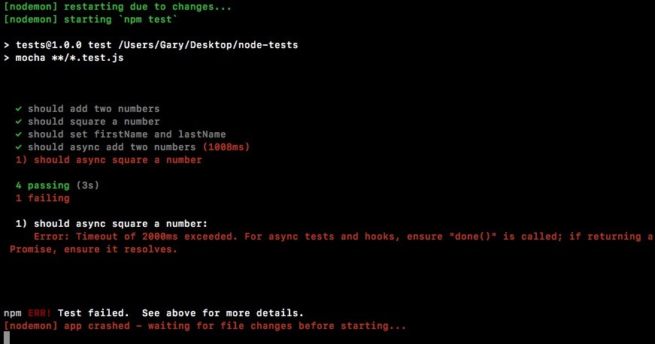

You're getting an error timeout, the 2,000 milliseconds has exceeded. This is when Mocha cuts off your test. If you see this, this usually means two things:

You have an async function that never actually calls the callback, so you're call to done never gets fired. You just never called done.

*If you see this message, it usually means there's a small typo somewhere in the async function. To overcome this, either fix things in the method (utils.js) by making sure the callback is called, or fix things in the test (utils.test.js) by calling done, and when you save the file you should now see all of your tests are passing.*

In our case, we have 5 tests passing and it took 2 seconds to do that. This is fantastic:

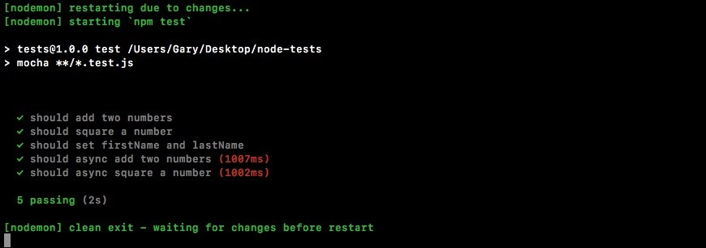

We now have a way to test synchronous functions and asynchronous functions. This will make testing a lot more flexible. It'll let us test essentially everything inside of our applications.

**Summary**

In this chapter, we looked into testing the synchronous and asynchronous functions. We looked into basic testing. We explored the testing framework, Mocha. Then, we look into using assertion libraries in testing Node modules.

In the next chapter, we'll look at how we can test our Express apps.

**Testing the Node Applications – Part 2**

In this chapter, we'll continue our journey of testing the Node applications. In the previous chapter, we looked at the basic testing framework and worked on synchronous as well as asynchronous Node application. In this chapter we'll move on to testing the Express applications, then we'll look into a method to organize our test better in the result output, and last but not least we'll get into some advanced methods of testing Node application.

Specifically, we'll look into the following topics:

Setting up testing for Express app

Testing Express application

Organizing test with describe()

Test spies

**Testing the Express application**

In this section, we'll be setting up an Express app and then, we'll look at how we can test it to verify that the data that comes back from our routes is what the user should be getting. Now before we do any of that, we will need to create an Express server and that's the goal of this section.

**Setting up testing for the Express app**

We'll start with installing Express. We'll use npm i, which is short for install, to install Express. Remember, you could always replace install with i. We'll grab the most recent version, @4.16.2. Now, we'll be using the save flag as opposed to the save dev flag that we've used for testing in the previous chapter: **npm i express@4.16.2 --save**

This command is going to install Express as a regular dependency, which is exactly what we want:

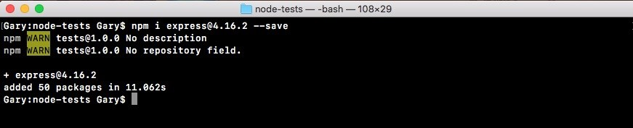

We need Express when we deploy to production, whether it's Heroku or some other service.

Back inside the app, if we open up package.json, we can see we have dependencies which we've seen before, and devDependencies which is new to us:

"devDependencies": {

"expect": "^1.20.2",

"mocha": "^3.0.0"

},

"dependencies": {

"express": "^4.14.0"

}

}

This is how we can break up the different dependencies. From here, we'll make a server folder inside the root of the project where we can store the server example as well as the test file. We'll make a directory called server. Then inside server, we'll make a file called server.js.

The server.js file will contain the actual code that starts up our server. We'll define our routes, we'll listen to a port, all that stuff is going to happen in here. This is what we had before for the previous server chapter. In server.js, we'll add const express, and this will get equal to the require ('express') return result: const express = require('express');

Next up, we can make our application by creating a variable called app and setting it equal to a call to express:

const express = require('express'); var app = express();

Then we can start configuring our routes. Let's set up just one for this section,

app.get:

const express = require('express'); var app = express(); app.get

This will set up an HTTP GET handler. The URL will be just / (forward slash), the root of the website. And when someone requests that, for the moment we'll specify a really simple string as the return result. We get the request and the response object like we do for all of our express routes. Yo respond, we'll call res.send, sending back the string Hello World!:

app.get('/', (req, res) => { res.send('Hello world!');

});

The last step in the process will be to listen on a port using app.listen. We'll bind to port 3000 by passing it in as the first and only argument:

app.get('/', (req, res) => { res.send('Hello world!');

}); app.listen(3000);

With this in place, we are now done. We have a basic Express server. Before we move on to explore how to test these routes, let's start it up. We'll do that by using the following command:

**node server/server.js**

When we run this, we don't get any logs because we haven't added a callback function for when the server starts, but it should indeed be up.

If we go over to Chrome and visit localhost:3000, we get Hello world! printing to the screen:

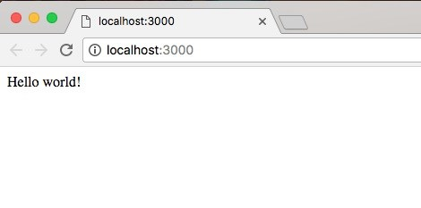

Now, we are ready to move on to start testing our Express application.

**Testing the Express app using SuperTest**

Now, we'll learn an easy, no-nonsense way to test our Express applications. That means we can verify that when we make an HTTP GET request to the / URL, we get the Hello world! response back.

Now traditionally, testing HTTP apps has been one of the more difficult things to test. We would have to fire up a server, like we did in the previous section. Then we would need some code to actually make the request to the appropriate URL. And then we have to dig through the response, getting what we want, and making assertions about it, whether it's headers, the status code, the body, or anything else. It is a real burden. That is not the goal for this section. Our goal here is to make testing easy and approachable, so we'll use a library called SuperTest to test our Express applications.

SuperTest was created by the developers who originally created Express. It has built-in support for Express and it makes testing your Express apps dead simple.

**The SuperTest documentation**

In order to get started, let's pull up the docs page so you know where it lives if you ever want to look at any other features that it has to offer. If you Google supertest, it should be the first result:

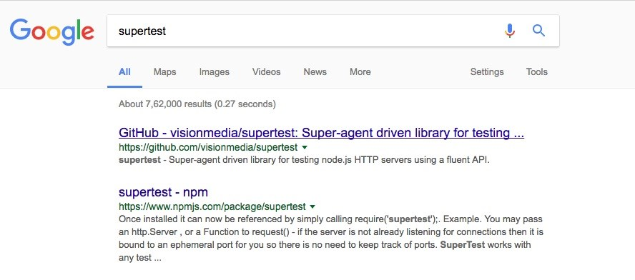

It's the VisionMedia repository and the repository itself is called SuperTest. Let's switch over to the repository page and we can take a quick look at what it has to offer. On this page, we can find installation instructions and introduction stuff.

We don't really need that. Let's take a quick look at an example:

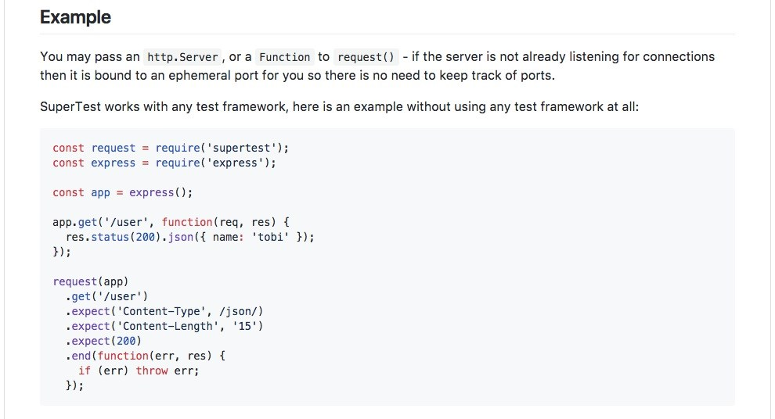

As shown in the previous screenshot, we can see an example of how SuperTest works. We create an Express application, just like we normally would, and we define a route. Then we make a call to the request method, which is provided by SuperTest, passing in our Express application. We say we want to make a get request to the / URL. Then we start making assertions. There's no need to manually check either the headers, the status code, or the body. It has built-in assertions for all of that.

**Creating a test for the Express app**

To get started, we'll install SuperTest in our application by running npm install from the Terminal. We have the Node server still running. Let's shut that down and then install the module.

We can use npm i, the module name is supertest and we'll be grabbing the most recent version, @2.0.0. This is a test-specific module so we'll be installing it with

save. We'll use

save-dev

to add it to the

devDependencies

in

package.json

:

**npm i supertest@3.0.0 --save-dev**

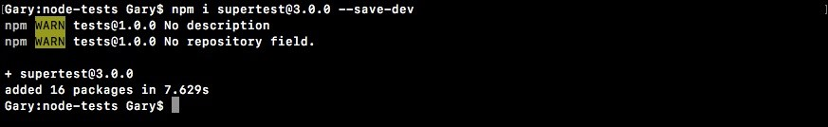

With SuperTest installed, we are now ready to work on the

server.test.js

file. As

it doesn't yet exist inside the server folder, so we can create it. It's going to sit just alongside server.js:

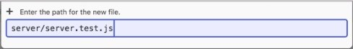

Now that we have server.test.js in place, we can start setting up our very first test. First, we'll be creating a constant called request and setting that equal to the return result from requiring supertest: const request = require('supertest');

This is the main method we'll be using to test our Express apps. From here, we can load in the Express application. Now inside server.js, we don't have an export that exports the app, so we'll have to add that. I'll add it next to the app.listen statement by creating module.exports.app and setting that equal to the app variable:

app.listen(3000); module.exports.app = app;

Now we have an export called app that we can access from other files. The server.js is still going to run as expected when we start it from the Terminal, not in test mode. We just added an export so if anyone happens to require it, they can get access to that app. Inside server.test.js, we'll make a variable to import this. We'll call the variable app. Then we'll require using require('./server.js'), or just server. Then we'll access the .app property:

const request = require('supertest'); var app = require('./server').app;

With this in place, we now have everything we need to write our very first test.

**Writing the test for the Express app**

The first test we'll write is a test that verifies when we make an HTTP GET request to the / URL, we get Hello world! back. To do this, we will be calling it just like we did for our other tests in the previous chapter. We're still using mocha as the actual test framework. We're using SuperTest to fill in the gaps:

var app = require('./server').app; it('should return hello world response')

Now we'll set up the function as follows:

it('should return hello world response', (done) => {

});

This is going to be an asynchronous call so I are providing done as the argument to let mocha know to wait before determining whether or not the test passed or failed. From here, we can now make our very first call to request. To use SuperTest, we call request passing in the actual Express application. In this case, we pass in the app variable:

it('should return hello world response', (done) => { request(app) });

Then we can start chaining together all the methods we need to make the request, make our assertions, and finally wrap things up. First up, you'll be using a method to actually make that request, whether it's a get, put, delete, or a post.

For now, we'll be making a get request, so we will use .get. The .get request takes the URL. So, we'll provide / (forward slash), just as we did in server.js:

it('should return hello world response', (done) => { request(app)

.get('/')

});

Next up, we can make some assertions. To make assertions, we'll use .expect.

Now .expect is one of those methods that does different things depending on what you pass to it. In our case, we'll be passing in a string. Let's pass in a string which will be the response body that we assert, Hello world!:

it('should return hello world response', (done) => { request(app)

.get('/')

.expect('Hello world!')

});

Now that we're done and we've made our assertions, we can wrap things up. To wrap up a request in SuperTest, all we do is we call .end passing in done as the callback:

it('should return hello world response', (done) => { request(app)

.get('/')

.expect('Hello world!')

.end(done);

});

This handles everything behind the scenes so you don't need to manually call done at a later point in time. All of it is handled by SuperTest. With these four lines (in the previous code), we have successfully tested our very first API request.

**Testing our first API request**

We'll kick things off in the Terminal by running our test-watch script: **npm run test-watch**

The test script is going to start and as shown here, we have some tests:

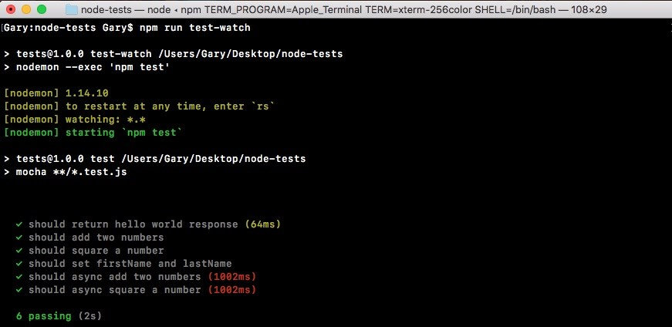

We have our test, should return hello world response, showing up in the previous screenshot.

Now we can take things a step further making other assertions about the data that comes back. For example, we can use expect after the .get request in server.test.js to make an assertion about the status code. By default, all of our Express calls are going to return a 200 status code, which means that things went

OK:

it('should return hello world response', (done) => { request(app) .get('/')

.expect(200)

.expect('Hello world!')

.end(done);

});

If we save the file, the test still passes:

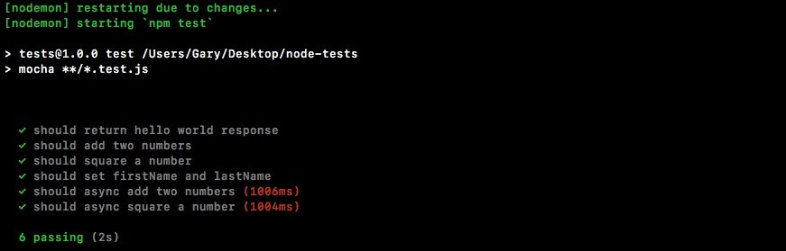

Now let's make some changes to the request to make these tests fail. First up, in server.js we'll just add a few characters (ww) to the string, and save the file:

app.get('/', (req, res) => { res.send('Hello wwworld!');

});

app.listen(3000); module.exports.app = app;

This should cause the SuperTest test to fail and it does indeed do that:

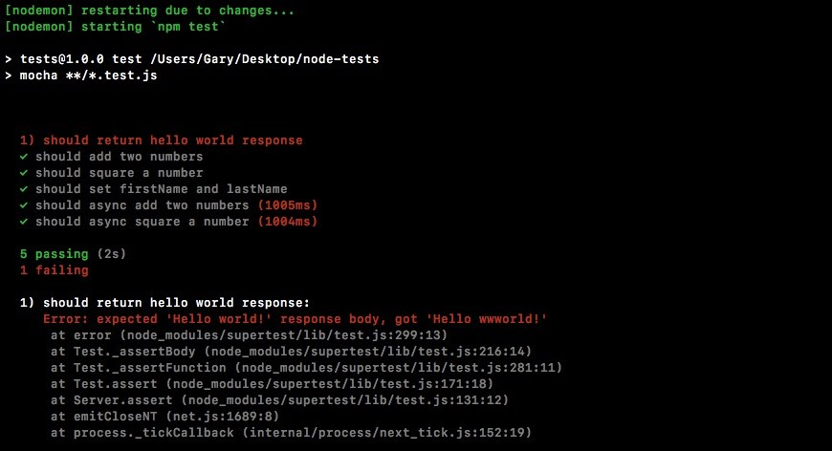

As shown in the previous screenshot, we get a message, expected 'Hello world!' response body, but we got 'Hello wwworld!'. This is letting us know exactly what happened. Back inside server.js, we can remove those extra characters (ww) and try something else.

**Setting up custom status**

Now we haven't talked about how to set a custom status for our response, but we can do that with one method, .status. Let's add .status in server.js, chaining it on, before, send('Hello world!'), just like this:

app.get('/', (req, res) => { res.status().send('Hello world!');

});

Then, we can pass in the numerical status code. For example, we could use a 404 for page not found:

app.get('/', (req, res) => {

res.status(404).send('Hello world!');

});

If we save the file this time around, the body is going to match up, but inside the Terminal we can see we now have a different error:

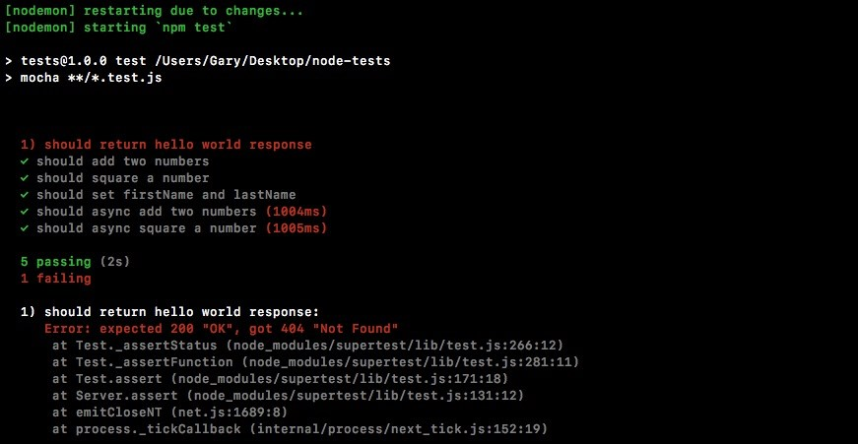

We expected a 200, but we got a 404. Using SuperTest, we can make all sorts of assertions about our application. Now the same thing is true for different types of responses. For example, we can create an object as the response. Let's make a simple object and we'll create a property called error. Then we'll set error equal to a generic error message for a 404, something like Page not found:

app.get('/', (req, res) => { res.status(404).send({ error: 'Page not found.'

});

});

Now, we're sending back a JSON body, but currently we're not making any assertions about that body so the test is going to fail:

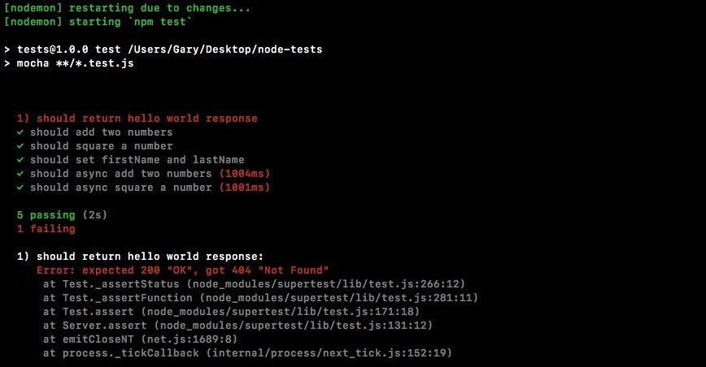

We can update our tests to expect JSON to come back. In order to get that done, all we have to do inside server.test is change what we pass to expect. Instead of passing in a string, we'll pass in an object:

it('should return hello world response', (done) => { request(app) .get('/')

.expect(200) .expect({

})

.end(done);

});

Now we can match up that object exactly. Inside the object, we'll expect that the error property exists and that it equals exactly what we have in server.js:

.expect({

error: 'Page not found.'

})

Then, we'll change the .expect call to a 404 from 200:

.expect(404)

.expect({

error: 'Page not found.'

})

With this in place, our assertions now match up with the actual endpoint we've defined inside the Express application. Let's save the file and see if all the tests pass:

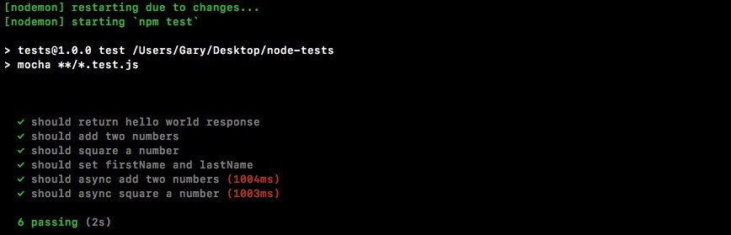

As shown in the previous screenshot, we can see it is indeed passing. The Should return hello world response is passing. It took about 41ms (milliseconds) to complete, and that is perfectly fine.

**Adding flexibility to SuperTest**

A lot of the built-in assertions do get the job done for the majority of cases. There are times where you want a little more flexibility. For example, in the previous chapter, we learned about all those cool assertions expect can make. We can use toInclude, toExclude, all of that stuff is really handy and it's a shame to lose it. Luckily, there's a lot of flexibility with SuperTest. What we can do instead of taking an object and passing it into expect, or a number for the status code, we can provide a function. This function will get called by SuperTest and it will get passed the response:

.expect((res) => {

})

This means we can access headers, body, anything we want to access from the HTTP response—it's going to be available in the function. We can pipe it through the regular expect assertion library like we've done in the previous chapter.

Let's load it in, creating a constant called expect and setting it equal to require

expect:

const express = require('supertest'); const express = require('express');

Now before we look at how it's going to work, we'll make a change in server.js. Here, we'll add a second property on to the .status object. We'll add an error and then add something else. Let's use name, setting it equal to the application name,

Todo App v1.0:

app.get('/', (req, res) => { res.status(404).send({ error: 'Page not found.', name: 'Todo App v1.0'

});

});

Now that we have this in place, we can take a look at how we can use those custom assertions inside our test file. In the .expect object, we'll have access to the response and in the response there is a body property. This will be a JavaScript object with key-value pairs, which means we would expect to have an error property and a name property, which we set in server.js.

Back inside our test file, we can make a custom assertion using expect. I'll expect something about the body, res.body. Now we can use any assertion we like, not just the equals assertion, which is the only one SuperTest supports. Let's use the toInclude assertion:

.expect((res) => { expect(res.body).toInclude({

});

})

Remember, toInclude lets you specify a subset of the properties on the object. As long as it has those ones that's fine. It doesn't matter that it has extra ones. In our case, inside toInclude, we can just specify the error message, leaving off the fact that name exists at all. We want to check that error: Page not found, formatted exactly like we have it inside of server.js:

.expect((res) => { expect(res.body).toInclude({ error: 'Page not found.'

});

})

Now when we save the file back inside the Terminal, things restart and all of my tests are passing:

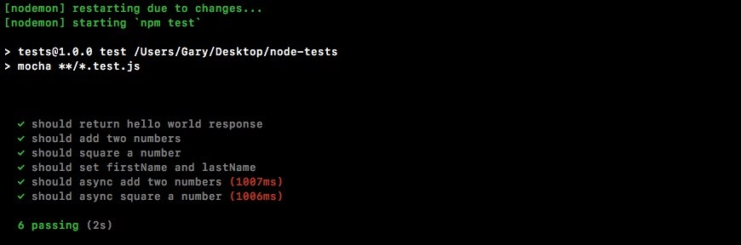

Using a combination of SuperTest and expect we can have super flexible test suites for our HTTP endpoints. With this in place, we'll create another express route and we'll define a test that makes sure it works as expected.

**Creating an express route**

There will be two sides to this express route, the actual setup in server.js and the test. We can start inside server.js. In here, we'll make a new route. First, let's add a few comments to specify exactly what we'll do. It's going to be an HTTP GET route. The route itself will be /users and we can just assume this returns an array of users:

app.get('/', (req, res) => { res.status(404).send({ error: 'Page not found.', name: 'Todo App v1.0'

});

});

// GET /users

We can pass an array back through the send method, just like we do an object in the previous code. Now this array is going to be an array of objects where each object is a user. For now, we want to give users a name property and an age prop:

// GET /users

// Give users a name prop and age prop

Then we'll create two or three users for this example. Now once we have this done, we'll be responsible for writing a test that asserts it works as expected.

That's going to happen in server.test.js. Inside server.test.js, we'll make a new test:

it('should return hello world response', (done) => { request(app) .get('/')

.expect(404) .expect((res) => { expect(res.body).toInclude({ error: 'Page not found.'

});

})

.end(done); });

// Make a new test

And this test is going to assert a couple of things. First up, we assert that the status code that comes back is a 200 and we want to make an assertion that inside of that array and we'll do that using toInclude:

// Make a new test

// assert 200

// Assert that you exist in users array

Let's start with defining the endpoint first. Inside server.js, just following the comments, we'll call app.get so we can register the brand new HTTP endpoint for our application. This one is going to be at /users:

app.get('/users')

// GET /users

// Give users a name prop and age prop

Next up, we'll specify the callback that takes both request and response:

app.get('/users', (req, res) => {

});

// GET /users

// Give users a name prop and age prop

This will let us actually respond to the request, and the goal here is just to respond with an array. In this case, I'll call response.send passing in an array of objects:

app.get('/users', (req, res) => { res.send([{

}])

});

The first object will be name. We'll set the name equal to Mike and we'll set his age equal to 27:

app.get('/users', (req, res) => { res.send([{ name: 'Mike', age: 27

}])

});

Then I can add another object. Let's add the second object to the array with a name equal to Andrew and an age equal to 25:

app.get('/users', (req, res) => { res.send([{ name: 'Mike', age: 27 }, { name: 'Andrew',

age: 25

}])

});

In the last one, we'll set the name equal to Jen and the age equal to 26:

app.get('/users', (req, res) => { res.send([{ name: 'Mike', age: 27 }, { name: 'Andrew', age: 25 }, { name: 'Jen', age: 26

}])

});

Now that we have our endpoint done, we can save server.js, move into server.test.js, and start worrying about actually creating our test case.

**Writing the test for the express route**

In server.test.js, just following the comments, we need to start things out by calling it. it is the only way to make a new test:

// Make a new test

// assert 200

// Assert that you exist in users array it('should return my user object')

Then we'll specify the callback function. It will get past the done argument because this one is going to be asynchronous:

// Make a new test

// assert 200

// Assert that you exist in users array it('should return my user object', (done) => {

});

To kick things off inside the test case, we'll be calling requests just like we did in hello world response, passing in the Express application:

it('should return my user object', (done) => { request(app) });

Now we can set up the actual call. In this case, we're just making a call, a get request, to the following URL, inside of quotes, /users:

it('should return my user object', (done) => { request(app)

.get('/users')

});

Next up, we can start making our assertions and the first thing we're supposed to assert that the status code is at 200, which is the default status code used by Express. We can assert that by calling .expect and passing in the status code as a number. In this case, we'll pass in 200:

it('should return my user object', (done) => { request(app) .get('/users')

.expect(200)

});

After this, we'll use a custom expect assertion. This means that we'll call expect passing in a function and use toInclude inside it to make the assertion that you exist in that users array. We'll call expect the method passing in the function, and that function will get called with the response:

it('should return my user object', (done) => { request(app) .get('/users')

.expect(200)

.expect((res) => {

})

});

This will let us make some assertions about the response. What we're actually going to do is make an assertion using expect. We'll expect something about the response body. In this case, we'll be checking that it includes using toInclude, our user object:

it('should return my user object', (done) => { request(app) .get('/users')

.expect(200) .expect((res) => {

expect(res.body).toInclude()

})

});

Now remember you can call toInclude on both arrays and objects. All we do is pass in the item we want to confirm is in the array. In our case, it's an object where the name property equals Andrew and the age property equals 25, which is what we used inside server.js:

expect(res.body).toInclude({ name: 'Andrew', age: 25 })

Now that we have our custom expect call in place, at the very bottom we can call .end. This is going to wrap up the request and we can pass in done as the callback so it can properly fire off those errors if any actually occurred:

expect(res.body).toInclude({ name: 'Andrew', age: 25

})

})

.end(done);

With this in place, we are ready to get going. We can save the file.

Inside the Terminal, we can see the tests are indeed rerunning:

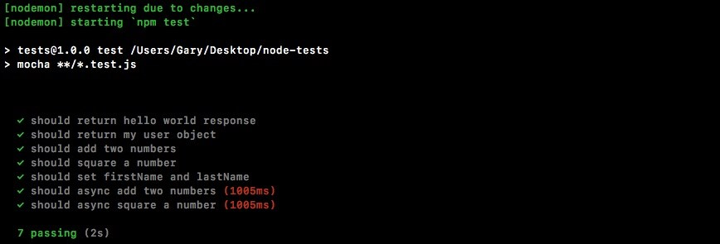

We have a test as shown in the previous screenshot, should return my user object. It is passing.

Now we can confirm that we'll not go crazy and test the wrong thing by just messing up the data. We will now add a lowercase a after the uppercase one in Andrew in server.js, as shown here:

app.get('/users', (req, res) => { res.send([{ name: 'Mike', age: 27 }, { name: 'Aandrew', age: 25 }, { name: 'Jen', age: 26

}])

});

The test is going to fail. We can see that in the Terminal:

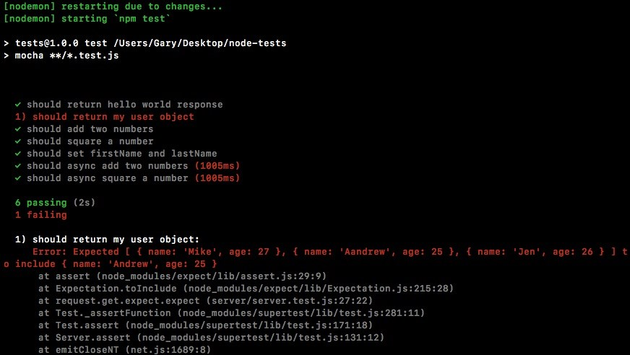

We have done testing for our Express apps. We'll now talk about one more way we can test our Node code.

**Organizing test with describe()**

In this section, we will learn how to use describe(). describe is a function injected into our test files, just like the it function is. It comes from mocha and it's really fantastic. Essentially, it lets us group tests together. That makes it a lot easier to scan the test output. If we run our npm test command in the Terminal, we get our tests:

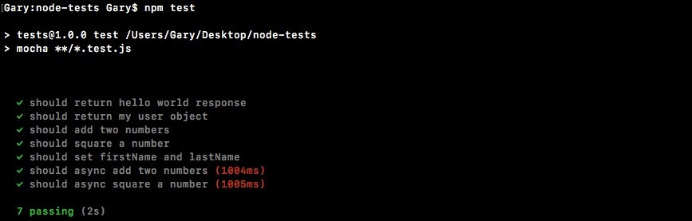

We have seven tests and currently they're all grouped together. It's really hard to look for the tests in the utils file and it's impossible to find the tests for asyncAdd without scanning all of the text. What we'll do is call describe(). This will let us make groups of tests. We can give that group a name. It will make our test output much more readable.

In the utils.test.js file, right after the utils constant, we'll call describe():

const expect = require('expect'); const utils = require('./utils'); describe()

The describe object takes two arguments, just like it. The first one is the name and the other is the callback function. We'll use Utils. This will be the describe block that contains all of the tests in the utils.test file. Then we'll provide the function. This is the callback function:

describe('Utils', () => {

});

Inside the callback function, we'll be defining tests. Any test defined in the callback function will be a part of the utils block. That means we can take our existing tests, cut them out of the file, paste them in there, and we'll have a describe block called utils with all of the tests for this file. So, let's do just that.

We'll grab all the tests, excluding the ones that are just playground tests where we play around with various expect functionality. We'll then paste them right into the callback function. The resultant code is going to look like this:

describe('Utils', () => { it('should add two numbers', () => { var res = utils.add(33, 11);

expect(res).toBe(44).toBeA('number');

});

it('should async add two numbers', (done) => { utils.asyncAdd(4, 3, (sum) => { expect(sum).toBe(7).toBeA('number'); done();

}); });

it('should square a number', () => { var res = utils.square(3);

expect(res).toBe(9).toBeA('number');

});

it('should async square a number', (done) => { utils.asyncSquare(5, (res) => { expect(res).toBe(25).toBeA('number'); done();

});

});

});

These are four tests for add, asyncAdd, square, and asyncSquare respectively. Now we'll save the file and we can start up the test-watch script from the Terminal and check the output: **npm run test-watch**

The script will start and run through our tests, and as shown in the following screenshot, we'll have different outputs:

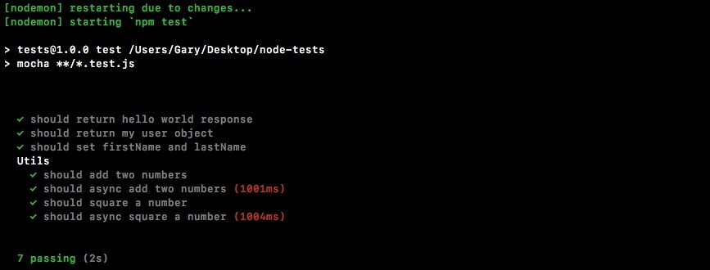

We have a Utils section and under Utils, we have all of the tests in that describe block. This makes reading and scanning your tests much, much easier. We can do the same thing for the individual methods.

**Adding describe() for individual methods**

Now, in the case of utils.test.js (refer to the previous screenshot), we have one test per method, but if you have a lot of tests that are targeting a complex method, it's best to wrap that in its own describe block. We can nest describe blocks and tests in any way we like. For example, right inside utils just after the describe statement, we can call describe again. We can pass a new description.

Let's use # (pound sign) followed by add:

describe('Utils', () => { describe('#add')

The # (pound sign) followed by the method name is the common syntax for adding a describe block for a specific method. Then we can provide that callback function:

describe('Utils', () => { describe('#add', () => {

})

Then, we can take any tests we want to add into that group, cut them out, and paste them in:

describe('Utils', () => {

describe('#add', () => { it('should add two numbers', () => { var res = utils.add(33, 11);

expect(res).toBe(44).toBeA('number');

});

});

Then I can save the file. This will rerun the test suite and now we have test output that's even more scannable:

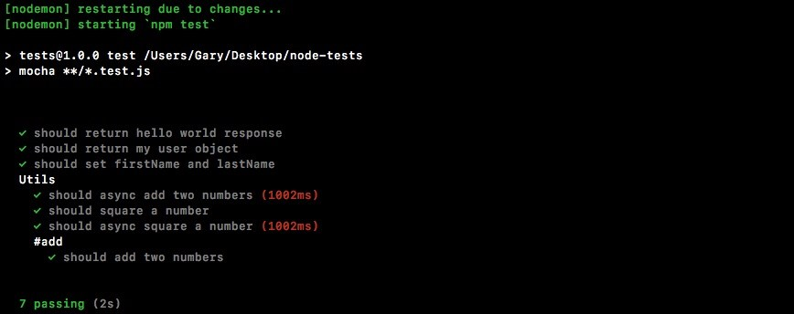

It's super easy to find the utils add method tests because they're clearly labelled. Now you could go as crazy or as uncrazy with this as you want. There really is no hard-and-fast rule for how often to use describe to structure your tests. It's really up to you to figure out what makes sense given the amount of tests you have for a method or a file.

In this case, we have quite a few tests in the file so it definitely makes sense to add that utils block. And I just wanted to show you you could nest them, so I added it for add as well. If I was writing this code, I probably wouldn't add a second layer of tests, but if I had more than one test per method, I definitely would add a second describe block.

**Adding the route describe block for the server.test.js file**

Now, let's create some describe blocks in the server.test file. We'll create a route describe block called Server. Then we'll create describe blocks for both the route URL and for /users. We'll have GET/. That will have the test case in there, some test case. Then alongside //, we'll have GET /users, and that will have its own test case, some test case as explained in the comments next:

const request = require('supertest'); const expect = require('expect'); var app = require('./server').app;

// Server

// GET /

// some test case // GET / user

// some test case

Now the test cases are obviously already defined. All we need to do is call describe three times to generate the previously explained structure.

We'll start with calling describe() once following the comments part, and this description will be for the route, so we'll call this one Server:

// Server

// GET /

// some test case // GET / user

// some test case

describe('Server')

This is going to contain all the tests in our server file. We can add the callback function next and we can move on:

describe('Server', () => {

})

Next up, we'll call describe again. This time we're creating a describe block for tests that test the GET / route and add the callback function:

describe('Server', () => {

describe('GET /', () => {

})

})

Now we can simply take our test, cut it out, and paste it right inside the describe callback. The resultant code is going to look like this:

describe('Server', () => {

describe('GET /', () => { it('should return hello world response', (done) => { request(app) .get('/')

.expect(404) .expect((res) => { expect(res.body).toInclude({ error: 'Page not found.'

});

})

.end(done);

}); });

})

Next up, we'll call describe the third time. We'll be calling describe passing in as the description GET /users: describe('GET /users')

We'll have our callback function as always and then we can copy and paste our test right inside:

describe('GET /users'), () => { it('should return my user object', (done) => { request(app) .get('/users')

.expect(200) .expect((res) => { expect(res.body).toInclude({ name: 'Andrew', age: 25

});

})

.end(done);

});

});

With this in place, we are now done. We have a much better structure for our tests and when we rerun the test suite by saving the file, we'll be able to see that in the Terminal:

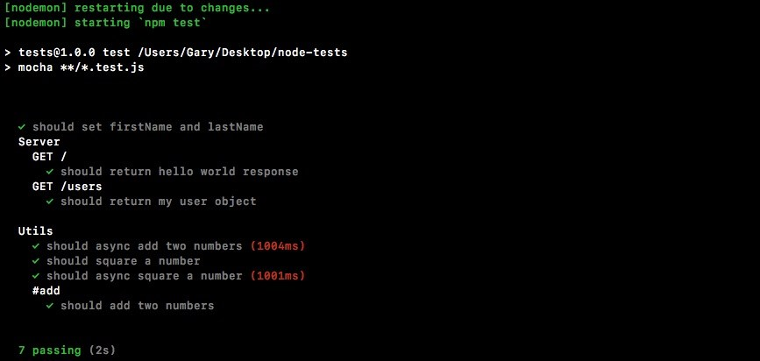

As shown in the previous code, we have a much more scannable test suite. We can see our server tests right away. We can create groups of tests for each feature. Since we have static data right now, we really don't need more than one test per feature. But down the line, we will have multiple tests for each of our HTTP requests, so it's a good idea to get into that habit of creating describe blocks early. And that's it for this one!

**Test spies**

In this section, which is the final section for the testing chapter, we'll learn some pretty advanced testing techniques. We'll be using these techniques as we build real-world apps, but for now let's start off with an example. We'll worry about the vocabulary for what we're about to do in just a second.

For the moment, we'll close all our current files and create a new directory in the root of the project. We'll make a new folder called spies. We'll talk about what exactly spies are and how they relate to testing in just a moment. Inside spies, we'll make two files: app.js (this is the file that we'll be testing) and a second one, called db.js. In our example, we can just assume that db.js is a file that has all sorts of methods for saving and reading data from the database.

Inside db.js, we'll create one function using module.exports. Let's create a function called saveUser. The saveUser function will be a really simple function, and it will take a user object like this:

module.exports.saveUser = (user) => {

}

Now, we'll just print it to the screen using the console.log statement. We'll print it a little message, Saving the user, and we'll also print out the object as shown here:

module.exports.saveUser = (user) => { console.log('Saving the user', user); }

Now obviously, this is not a real saveUser function. We do not interact with any sort of database, but it will illustrate exactly how we will be using spies to test our code.

Next up, we will fill our app.js, and this is the file we'll actually be testing. Inside app.js, we'll create a new function: module.exports.handleSignup. In the context of an application with authentication, handleSignup might take an email and a password; maybe it goes ahead and checks if the email already exists. If it doesn't, great; it saves the user and then it sends some sort of a welcome email. We can simulate that by creating an arrow function (=>) that takes in email and a password:

module.exports.handleSignup = (email, password) => {

};

Inside the arrow function (=>), we'll leave three comments. These will be things that the function is supposed to do. It will check if the email already exists; it will save the user to the database; and finally, we'll send that welcome email:

module.exports.handleSignup = (email, password) => {

// Check if email already exists

// Save the user to the database

// Send the welcome email

};

Now, these three things are just an example of what a handleSignup method might actually do. When we go through the real process, you'll see how it pans out. Now, we already have one of these in place. We just created saveUser, so we'll do is call saveUser instead of having this second comment:

// Check if email already exists db.saveUser()

// Send the welcome email

It's not imported just yet, but that's not going to stop us from calling it; we'll add the import in just a second, and we'll pass in what it expects, the user object. Now, we don't have a user object; we have an email and a password. We can create that user object by setting email equal to the email argument and setting password equal to the password argument:

db.saveUser({ email: email, password: password

});

Now one important thing to note: inside ES6, if the property name in an object you're setting is the same as the variable name, you can actually define it like this:

db.saveUser({ email, password });

In this example, since we're setting a password property equal to whatever on the password variable, there's no need to have both. This ES6 syntax also allows us to create a much simpler-looking call. There's no need to have it on multiple lines since it's pretty reasonable in length.

Now, at the top, we can load in db by creating a variable, calling it db, and setting it equal to require('db.js'). That is a local file, so we'll start it with a ./ to grab it from the current directory: var db = require('./db.js');

Now, this is an example of something that we'll want to test inside our code. We have a handleSignup method. It takes an email and a password, and we need to make sure that db.saveUser works as well. That is a big problem, and this means that we're not just testing handleSignup, we are also testing the following:

We're testing handleSignup

We're testing our code that checks if an email exists

Maybe that allows another function

We're checking if the saveUser function works as expected we're checking if the welcome email is sent

This is a real pain. What we'll do instead is fake the saveUser function. It's never actually going to execute the code inside it db, but it will let us verify that when we run handleSignup, saveUser gets called. We're going to do this with something called spies.

The spies function let you swap out a real function such as saveUser for a testing utility. When that test function gets called we can create various assertions about it, making sure it was called with certain arguments. Let's start exploring that.

**Creating a test file for spies**

We'll start it with creating a new file. Inside the spies directory, we'll make a new file called app.test.js, and we can start playing around with spies. Now, spies comes built-in with expect, so all we have to do is load it in: const expect = require('expect');

From here we can create our very first test. We'll put this in a describe block so it's easier to find over in our test output:

const expect = require('expect'); describe('')

We'll call this describe block App and we'll add my callback function:

describe('App', () => {

});

Now we can add individual test cases. First up, we'll call it and make a new test where we can just play around with spies:

describe('App', () => {

it('')

});

We won't be calling the function in our app.js file just yet. We'll add in the it object a string say, Should call the spy correctly:

describe('App', () => {

it('should call the spy correctly', () => {

});

});

In order to visualize how spies work, we'll go through the most basic example we can. First up, creating a spy.

**Creating a spy**

To create a spy, we'll call a function expect.createSpy inside the it callback function:

it('should call the spy correctly', () => { expect.createSpy();

});

The createSpy is going to return a function, and that is the function that we'll swap out for the real one, which means we do want to store that in a variable. I'll create a variable called spy, setting it equal to the returned result:

it('should call the spy correctly', () => { var spy = expect.createSpy();

});

And now we would inject spy into our code, whether it's app.js or some other function, and we would wait for it to get called. We can call it directly just like this:

it('should call the spy correctly', () => { var spy = expect.createSpy(); spy(); });

**Setting up spies assertions**

Next up, we can set up a series of assertions using expect's spies assertions by heading over to the browser and going to the expect documentation, mjackson expect (<https://github.com/mjackson/expect>).

On this page, we can scroll down to the spies section, where they talk about all the assertions we have access to. We should start seeing spies in the method names, and that's when we know we've gotten there:

&gt;

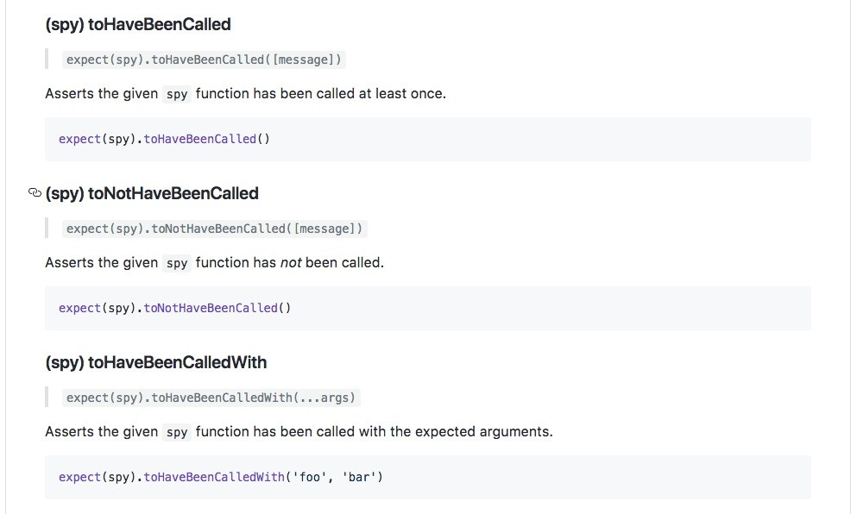

As shown in the previous code, we have the toHaveBeenCalled function and this is our first assertion with spies. We can assert that our spy was indeed called. Inside Atom, we'll do that by calling expect and passing in the spy, just like this:

it('should call the spy correctly', () => { var spy = expect.createSpy(); spy(); expect(spy)

});

Then, we'll add the assertion, toHaveBeenCalled: expect(spy).toHaveBeenCalled();

This will cause the test to pass if spy was called, which it was, and it'll cause the test to fail if the spy was never called. We can run the test suite inside the Terminal using the npm run test-watch command, and this is going to kick off the tests using nodemon:

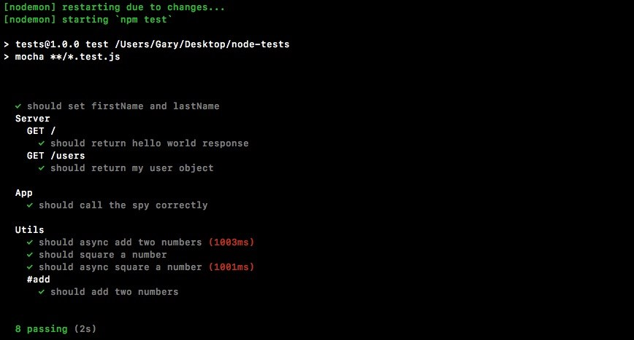

As shown in the previous screenshot, we have all our test cases, and under the

App one, we have should call the spy correctly. It did indeed pass, which is fantastic.

Now let's comment out the line where I call spy:

it('should call the spy correctly', () => { var spy = expect.createSpy();

// spy();

expect(spy).toHaveBeenCalled();

});

And this time around, the test should fail because spy was never actually called, and as shown in the following screenshot, we see spy was not called:

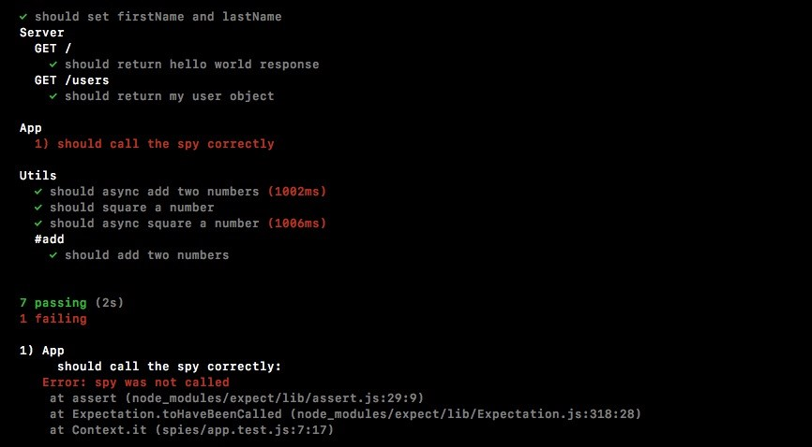

**More details out of spy assertion**

Now, checking if a spy was called or not called is great, but we can get even more detail out of our assertions. For example, what if I call the spy with the name Andrew and the age 25:

it('should call the spy correctly', () => { var spy = expect.createSpy(); spy('Andrew', 25);

expect(spy).toHaveBeenCalled();

});

Now, we want to verify if the spy was not just called but was called with these arguments? Well, luckily, we have an assertion for that too. Instead of toHaveBeenCalled, we can call toHaveBeenCalledWith, and this lets us pass in some arguments and verify the spy was indeed called with those arguments.

As shown in the following code, we'll assert that my spy was called with Andrew and the number 25: expect(spy).toHaveBeenCalledWith('Andrew', 25);

When we save the file and the test cases restart, we should see all the tests passing, and that's exactly what we get:

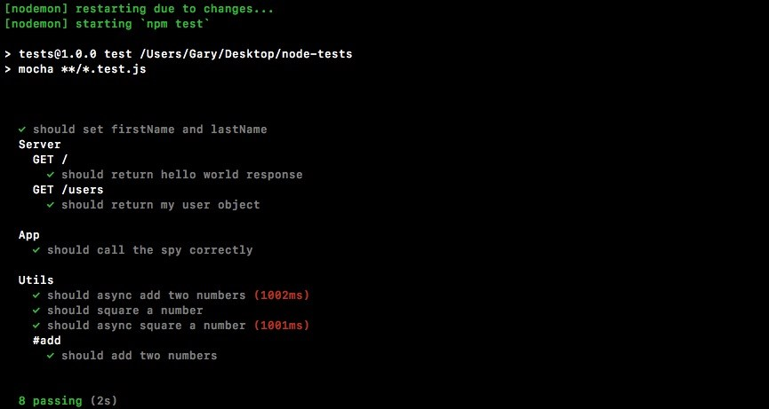

Now, if the spy was not called with the mentioned data, I'll remove 25:

it('should call the spy correctly', () => { var spy = expect.createSpy(); spy('Andrew'); expect(spy).toHaveBeenCalledWith('Andrew', 25); });

Now if we rerun the test suite, the test will fail. It will give you an error message letting you know that spy was never called with [ 'Andrew', 25 ]. This is causing the test to fail, which is fantastic.

*There are plenty of other assertions we can use with our spies. You can find them in the expect docs. We have toHaveBeenCalled, which we used; toNotHaveBeenCalled, verifying that a spy was not called. Then we have toHaveBeenCalledWith, which we also used. You can see there's a lot more to spies as well: how to create spies, which we've already done, and a few other methods.*

**Swapping of the function with spy**

For our purposes, we need a spy so we can simulate that function inside of app.js (saveUser). We need a way to replace saveUser function with a spy. Then we can verify that when handleSignup gets called, it does indeed call saveUser. It doesn't need to actually go through the process over in db.js; this is not important to our tests. The only thing that is important is that the function was called with the correct arguments.

To do that, we'll look at an npm module called rewire, which lets us swap out variables for our tests. In our case, in our test file, we'll be able to replace the db object with something else completely. Then, when the code runs, instead of calling db.saveUser as defined in app.js, it will be calling db.saveUser, which will be a spy.

**Installing and setting up the rewire function**

To get started, we do need to install rewire in the Terminal. It's a fantastic test utility. It's pretty essential for testing functions with side effects, like the one we have seen in this section. Let's run npm install. The module name itself is called rewire, and we'll be grabbing the most recent version as of this filming, version @3.0.2. This is a test-specific module. We'll not need it for our application to run regularly, so we will be using the --save-dev flag to add it to our package.json dependencies list:

**npm install rewire@3.0.2 --save-dev**

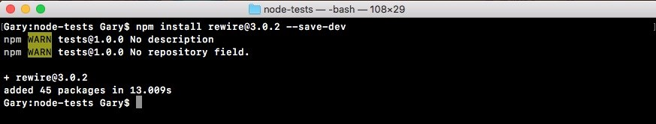

Once the module is installed we can get started using it, and it's pretty simple to

set up. Inside app.test.js we can start by loading it in. Up at the very top, we'll create a new constant. This one will be called rewire, and we'll set it equal to the returned result from requiring rewire:

const expect = require('expect'); const rewire = require('rewire');

**Replacing db with the spy**

Now, the way that rewire works is it requires you to use rewire instead of require when you're loading in the file that you want to mock out. For this example, we want to replace db with something else, so when we load an app we have to load it in in a special way. We'll make a variable called app, and we'll set it equal to rewire followed by what we would usually put inside of require. In this case it's a relative file, a file that we created ./app will get the job done:

const expect = require('expect'); const rewire = require('rewire'); var app = rewire('./app');

Now rewire loads your file through require, but it also adds two methods onto app. These methods are:

app.__set__ app.__get__

We can use these to mock out various data inside of app.js. That means we'll make a simulation of the db object, the one that comes back from db.js, but we'll swap out the function with a spy.

Inside our describe block, we can kick things off by making a variable. This variable is going to be called db, and we'll set it equal to an object:

describe('App', () => { var db = {

}

The only thing we need to mock out in our case is saveUser. Inside the object, we'll define saveUser and then I'll set it equal to a spy by creating one using expect.createSpy, just like this:

describe('App', () => { var db = { saveUser: expect.createSpy()

};

Now we have this db variable, and the only thing left to do is replace it. We do that using app.__set__, and this is going to take two arguments:

describe('App', () => { var db = { saveUser: expect.createSpy()

}; app.__set__();

The first one is the thing you want to replace. We're trying to replace db, and we're trying to replace it with the db variable, which is our object that has the saveUser function:

describe('App', () => { var db = { saveUser: expect.createSpy()

}; app.__set__('db', db);

With that in place, we can now write a test that verifies that handleSignup does indeed call saveUser.

**Writing a test to verify swapping of the function**

To verify if handleSignup calls saveUser, inside app.test.js, we'll call it:

describe('App', () => { var db = { saveUser: expect.createSpy()

};

app.__set__('db', db);

it('should call the spy correctly', () => { var spy = expect.createSpy(); spy('Andrew', 25); expect(spy).toHaveBeenCalledWith('Andrew', 25);

}); it('should call saveUser with user object')

Then we can pass in our function, and this is what will actually run when the test gets executed, and there's no need to use any asynchronous done arguments. This will be a synchronous test for now:

it('should call saveUser with user object', () => {

});

Inside the callback function, we can come up with an email and a password that we'll pass in to handleSignup in db.js. We'll make a variable called email setting it equal to some email andrew@example.com, and we can do the same thing with the password, var password; we'll set that equal to 123abc:

it('should call saveUser with user object', () => { var email = 'andrew@example.com'; var password = '123abc';

});

Next up, we will call handleSignup. This is the function we want to test. We'll call app.handleSignup, passing in our two arguments, email and password:

it('should call saveUser with user object', () => { var email = 'andrew@example.com'; var password = '123abc';

app.handleSignup(email, password); });

Now at this point, handleSignup will get executed. This means that the code over here will run and it will fire db.saveUser, but db.saveUser is not the method in db.js; it's a spy instead, which means we can now use those assertions we just learned about.

Inside of the test case, we'll use expect to expect something about db; the variable .saveUser, which we set equal to a spy:

app.handleSignup(email, password); expect(db.saveUser)

We'll call .toHaveBeenCalledWith with an object because that is what db.js should have been called with. We'll use that same ES6 shortcut: email, password:

app.handleSignup(email, password); expect(db.saveUser).toHaveBeenCalledWith({email, password}); });

This creates an email attribute set to the email variable, and a password attribute set to the password variable. With this in place, we can now save our test file, and in the Terminal we can restart the test-watch script by using the up arrow key twice to rerun our npm run test-watch command. This is going to kick off our test suite, starting up all of our tests:

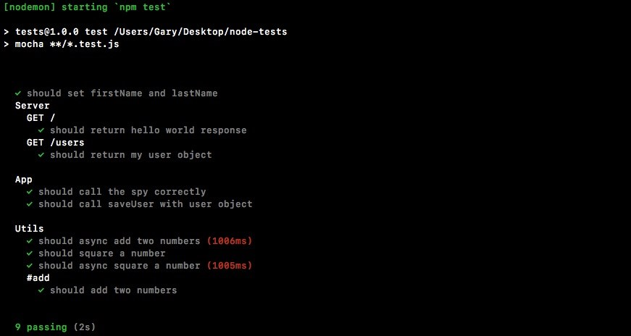

As shown in the previous screenshot, we see should call the spy correctly passes. Also, the test case we just created also passes. We can see should call saveUser with the user object, and this is fantastic. We now have a way to test pretty much anything inside Node. We can even test functions that call other functions, verifying that the communication happens as expected. All of this can be done using spies.

**Summary**

In this chapter, we looked into testing the Express applications as we did with the synchronous and async Node applications in the previous chapter. Then, we worked on organizing our tests with the describe() object so that we can see our different test methods right away.

In the last section we explored one more way we can test our Node applications, that is, spies. We created test files for spies, looked into the spy assertions and swapping of a function with spy.

**Conclusion**

That's the end of the book! Through the course of is book, you learned the fundamentals of Node.js so that you test and deploy Node.js applications on the web. We hope that you liked the journey this book has taken you through. We wish you all the success and hope that you continue to better your Node.js applications.

**Another Book You May Enjoy**

If you enjoyed this book, you may be interested in another book by Packt:



**Node Cookbook - Third Edition**

David Mark Clements, Mathias Buus, Matteo Collina, Peter Elger

ISBN: 978-1-78588-008-7

Debug Node.js programs

Write and publish your own Node.js modules

Detailed coverage of Node.js core API’s

Use web frameworks such as Express, Hapi and Koa for accelerated web application development

Apply Node.js streams for low-footprint data processing

Fast-track performance knowledge and optimization abilities

Persistence strategies, including database integrations with MongoDB,

MySQL/MariaDB, Postgres, Redis, and LevelDB

Apply critical, essential security concepts

Use Node with best-of-breed deployment technologies: Docker, Kubernetes and AWS

**Leave a review - let other readers know what you think**

Please share your thoughts on this book with others by leaving a review on the site that you bought it from. If you purchased the book from Amazon, please leave us an honest review on this book's Amazon page. This is vital so that other potential readers can see and use your unbiased opinion to make purchasing decisions, we can understand what our customers think about our products, and our authors can see your feedback on the title that they have worked with Packt to create. It will only take a few minutes of your time, but is valuable to other potential customers, our authors, and Packt. Thank you!